Brewing the Storm: Parent outburst overshadows Staunton girls' first win of basketball season
Patrick Hite
Staunton News Leader
STAUNTON — It was like watching a summertime thunderstorm from off in the distance. There was little sound, the thunder too far off to hear, but every few seconds brilliant flashes of light illuminated the darkness.
This Storm, the Staunton girls basketball team, was riding a yellow school bus headed north on Interstate 81 from Lexington. As the players slumped down in their seats, many were checking TikTok and Instagram or sending texts. As they did, the light from the phones flashed on then off, brightening for a few seconds an otherwise totally dark bus.
The only sound, other than occasional chatter from the players, came from the windows rattling on the bus as it bumped down the interstate toward Staunton.
You would have thought the trip home would have been a little more raucous. The team had won, beating Rockbridge by 22 points, for its first win of the young season. It was an important win for so early in the year. Staunton had already lost to Spotswood to start the season and was facing two tough road trips the following week — to Spotswood and to Turner Ashby. The Storm needed a win for, if nothing else, confidence.
The team also found the help it needed to complement seniors Emma Witt and Kellsye Miller. Those two can do a lot, but they can’t do it all.
Witt still led the way Friday with 37 points and Miller scored five, but four other players found their way into the scoring column. Fellow senior Sara Lotts had eight points, and freshman Sam Swift had seven. Kourtlyn Stewart and Neveah Henson scored four points each.
So a win and the emergence of a somewhat more balanced offense were reasons to be happy. The end of the game, however, was scarred by a couple of incidents.
Both Witt and Swift were hurt late in the game. An opponent’s knee hit Swift’s leg and left the freshman in tears. She spent a few minutes just limping around on the sidelines, trying to get rid of the pain.
Meanwhile, Witt caught an elbow to the mouth and immediately sprinted off the court and to the locker room with the Rockbridge athletic trainer in pursuit.
Coach Eric Payne said he'd never seen Witt react that way and really had no idea what was happening. What was happening was a bracket on Witt's braces punctured her lip and drew blood. Lots of blood.
Witt asked the trainer if she’d need stitches to close the hole in her lip. She was told she wouldn’t. After hearing that, Witt returned to the court and told Payne she was ready to go back in.
“I didn’t cry, though,” Witt, holding a bag of ice on her lip, told her teammates in the locker room after the game.
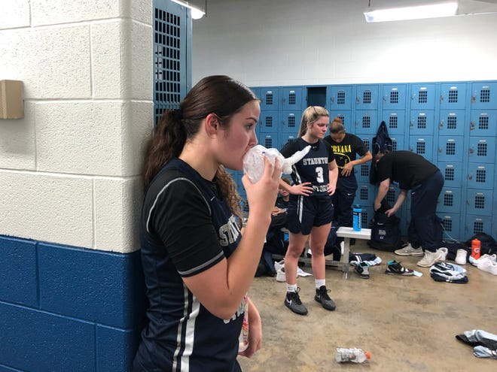
By the time Witt came back on the court, Swift had already returned to the game. She subbed in for a player, who was not too happy to come out. Neither was the player's dad, who was sitting behind and just to the right of the home team bench.
Before the game, Payne had told his players to be very disciplined and to "not do anything stupid tonight." He forgot to tell the parents that.
The dad began to yell at Payne and assistant coach Jamie Taylor, telling them they were “trash coaches.” He told Taylor that “me and you are going to have a talk after the game.” He again said they were terrible coaches, then looked at a newspaper reporter and said, “You can put that in the f------ paper.”
The player had left the bench during the game and headed to the locker room. By the time the game ended, she and her dad had already left the building. She didn’t ride home on the bus.
A Rockbridge administrator who had tried to intervene, telling the dad to set up a meeting with the coach for the following week, said after the game, as he was walking toward the scorer's table, that it was a shame parents acted like that because it only ruins things for the kids.
As Payne left the court, several other parents offered him words of encouragement. "Don't worry about that idiot," one said. "Good win, coach. Don't worry about that," another said.
Payne told his players in the locker room that he was happy with their composure down the stretch with everything that was happening. Then he apologized to the players who didn't get into the game — Amelia Nash, Holli Nash and JaNiyah Williams — telling them he knows the team was leading by a lot.
"But with everything that was going on, my mind was on a million other things," he said. "You'll get your opportunity."
Five hours earlier, sitting in his basketball office at Staunton High School, Payne related a story from a book he read about Bobby Knight.
The legendary Indiana University coach had told one of Aesop's fables, "The man, the boy and the donkey."
In that tale, a boy and his father are walking alongside their donkey to market when someone tells them donkeys are for riding. So the father puts his son on the donkey only to be told the son is lazy for letting his father walk. Then the father rides, only to be scolded for making his son walk. Then they both ride, but are told that's too much for the donkey.
“The moral is you can’t please everyone,” Payne said. Standing just outside the locker room at Staunton High Friday night around 10 p.m. Payne referred to the story again when talking about the incident with the parent.
“See," he said, “Bobby Knight was right. You can’t make everyone happy.”
Payne was asked if the player whose dad yelled at the coach would still be on the team. He said it was hard to imagine she would be considering she left during the game, but if there was an apology made to him it was possible she’d return. By Monday morning, her name was no longer on the roster.
But by Monday afternoon she was back at practice.
Payne was wearing a "Kindness Matters" t-shirt during practice Monday, the first day of Staunton City School's Kindness Challenge. The school division is challenging students, teachers, families, and the Staunton community to treat everyone with respect.
The coach seemed to take that challenge to heart. He told the players that his mother used to talk a lot about love and forgiveness. "Sometimes that's hard to do," he said, but when asked about the player the coach said he was willing to give her another chance.
The night ended with drama, but it began with something else Payne hates — disorganization.
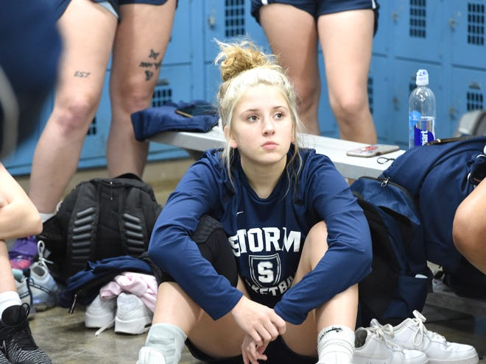
The plan was to leave Staunton High School for Lexington by 4:15 Friday afternoon. But when Sara Lotts carried a bag of balls to the waiting school bus outside the school around 4:20, she returned about a minute later, saying that was the bus taking the wrestling team to Charlottesville.
Eventually a bus arrived, albeit late, to take the basketball team to Lexington. Payne told all varsity players to head for the bus.
Sam Swift just stood there for a minute. Then the freshman, who played junior varsity last year, realized she was supposed to go also.
"I forgot we were on varsity," she said, laughing.
As the bus pulled out, someone yelled that a junior varsity player had been left behind. The bus had to circle around the bus loop and pick up the stranded player.
By the time the bus had left the high school, the team was 15 minutes behind schedule. After a 45-minute drive, the junior varsity players didn’t get to Rockbridge until there were 14 minutes left in warmups for their game, which is usually played before the varsity game.
As the varsity players waited in the locker room for the end of the first game, the team manager was asked to go see how much time was left. She returned, telling them the game was over. The players got their last minute instructions from Payne and headed for the court.
Turned out only the third quarter had ended, not the game. The players had to return to the locker room, where Payne had them do some meditation exercises to get calm before heading back out.
"Close your eyes," he told them. "Breathe in your nose. Exhale. Breathe in your nose. Exhale."
He got through maybe four repetitions before some of the players began to laugh. Then Payne had them get in a single file line and massage each others shoulders.
Then, when the coaches left the locker room, the players relaxed their own way, with loud music. No sooner had Payne stepped out into the hallway, they turned on “Richer” from rapper Rob Wave.
Payne coached for 16 years as an assistant women's basketball coach at Eastern Mennonite University. It was there that he saw how an organized program operates and he wants the same from his program at Staunton.
So things like a bus being late or coming out too early for warmups or a player misplacing her warmup jersey and having to search the locker room drive him crazy.
He doesn't mind the music.
It wasn't how he grew up playing the game at Wilson Memorial High School, but he said Brenda Frese, the University of Maryland women's coach, told him at a coaching clinic that you have to let players be themselves. A new generation of player might approach something differently than older players would, and that's OK. Payne tries to remember that when it comes to his teenage players.
He's not a fan, however, of the new generation of parents.
The News Leader published a story nearly 10 years ago about the issues schools were having with parents of athletes. Those parents were driving coaches and, at least on one case, athletes away from the game. It seemingly hasn't improved in that last decade.
More:Brewing the Storm: Emma Witt leads the way, but will the rest of the Staunton team follow?
— Patrick Hite is The News Leader's education and sports reporter. Story ideas and tips always welcome. Contact Patrick (he/him/his) at phite@newsleader.com and follow him on Twitter @Patrick_Hite. Subscribe to us at newsleader.com.

A secret revealed, a shot, then tears. Staunton star hits key milestone: Brewing the Storm
Patrick Hite
Staunton News Leader
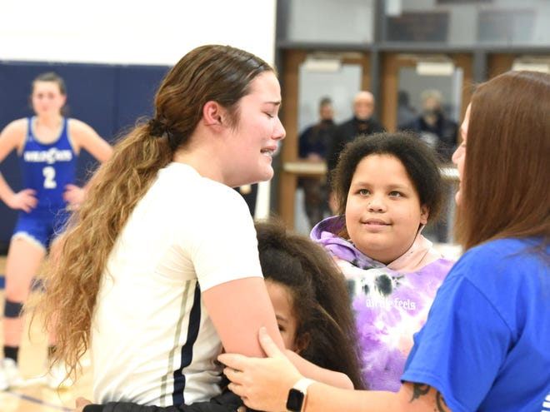
STAUNTON — The day after Staunton beat Rockbridge for its second win of the season, what Coach Eric Payne did was a bit unusual for a coach.
He held a practice and the players didn’t touch a basketball. Instead, he worked with them on relaxation techniques. He had them do some stretching. They did mirroring exercises. He worked on their breathing techniques.
He thought it was a good time to just take a break from practicing setting screens and getting out of traps, saying growth in basketball is not always about just playing basketball. He was trying to get his players to think about ways to calm themselves in the midst of chaos.
It was a good time, coming after a week of, if not exactly chaos, minor disruptions.
The craziness came to an end Wednesday night in Staunton’s win.

Milestone basket
Emma Witt looked like the astonished face emoji come to life.
With just over seven minutes left in a game against Rockbridge County, the Staunton senior stood at the free throw line. She had just given her team a 14-point lead with a drive to the basket, in which she was also fouled. She went to the line with a chance for a three-point play.
Witt dribbled once, then twice, spun the ball in her hands and shot it. The free throw missed everything, off to the right of the rim — the dreaded air ball.
At that point, Witt had scored 32 of her team’s 42 points. She was single-handedly outscoring Rockbridge by four points. And she was one point away from the 1,000th of her high school career.
When she missed the free throw, her mouth dropped open and she just turned around in shock. Witt has made 72.7% of her free throws this year, by percentage the second best on the team, but she’s also shot (33) almost as many free throws as the rest of the team combined (36) through five games.
If you didn’t know better, it was almost as if she knew that was the magic point she needed and got a case of the nerves, but after the game Witt swore that wasn’t the case. Her coach had worked hard to not let her know when she’d reach the milestone.
She had an inkling that it would be early in her senior year.
She had seen her coach talking to her mom and her mom’s boyfriend before the season started and, when she asked them what it was about, they gave her different answers. Witt knew something was up. She asked her coach for her point total coming into this season, but he said he didn’t have that available.
She texted the same question to The News Leader sports reporter, again without getting the answer she wanted.
So Witt knew it was going to happen, just not when.
Then, after her miss at the free throw line, more than seven minutes ticked off the clock without Witt scoring again. With less than 10 seconds to go, Staunton was going to win the game, the only question was if Witt would score her point.
Payne called a timeout with about a minute left and told her.
He wanted the 1,000th point scored that night, for multiple reasons. Witt’s mom’s boyfriend had made the trip to Staunton just in case it happened. Payne’s wife had made brownies. And, let’s be honest, while these moments are special, they’re also a bit of a distraction for the team. Payne didn’t want to go into the next game, the Shenandoah District opener against Buffalo Gap, with Witt still needing that point.
Finally, With 6.9 seconds remaining, Witt took an inbounds pass in the backcourt, dribbled to the left of the giant S in the center of the court, came back to the middle and pulled up just past the free throw line. She buried the shot.
Her teammates ran onto the court and mobbed her like she’d hit a game-winning basket in the playoffs. Payne presented her with a ball for the occasion and her mom came out of the stands for a hug. Witt was the first Staunton basketball player since Angela Mickens, who graduated in 2012, to reach 1,000-point milestone.
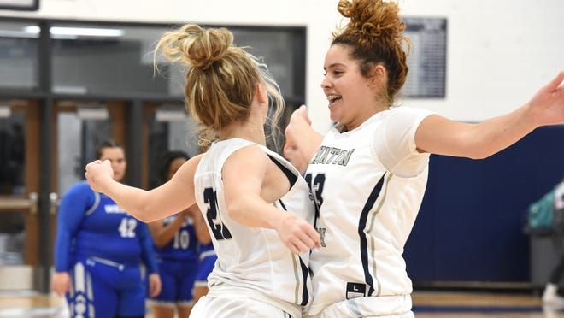

Wise teachings
That moment was fun for everyone around the program, but it was also chaotic. So were the two days of practice preceding it.
Monday was team picture day, which always creates a bit of havoc for any coach trying to run practice. Tuesday there was a wrestling match in the gym at 6 p.m., which meant Staunton’s girls had to end practice a half hour earlier than normal.
Exams were approaching, so was winter break. All things beyond a coach’s control, but still an annoyance.
Payne has studied yoga. He’s also studied a lot of Asian philosophies. And he’s a devout Christian. He says he never tries to push any religion on his players.
“I just try to exhibit the ways of these wise teachings,” he said. “People in sports talk about how teams take on their coach’s persona or their coach’s way of doing things.”
So relaxation is definitely part of what he is teaching. Payne is looking for something that can make his players a little different from players on other teams, that can maybe give them the edge in a game.
More in the series:When's a loss a win? Staunton girls fall short, but it was a huge step: Brewing the Storm
More in the series:Brewing the Storm: Parent outburst overshadows Staunton girls' first win of basketball season
More in the series:Brewing the Storm: Emma Witt leads the way, but will the rest of the Staunton team follow?
Millie Hicks is a junior on the team, but basketball isn’t her first sport. She’s a softball player, has been for a number of years. She’s learned a lot from Payne about core movements associated with basketball, things that don’t involve dribbling or shooting.
“It was fun,” Hicks said of that Thursday practice without a basketball. “I got to learn more about Coach Payne as a coach. He talks a lot about meditation and relaxing your mind because it helps your mentality as a player.”
Earlier this season, he led the team in some mediation exercises in the locker room at Rockbridge as a way to calm the players before taking the floor. So this wasn’t the first time he had talked about this with his players, but it was the fist time this season he’d dedicated a practice to it.
But he also wanted to see how closely the players paid attention to the exercises he was explaining to them.
“The big thing I was really trying to get across was paying attention to details,” Payne said.
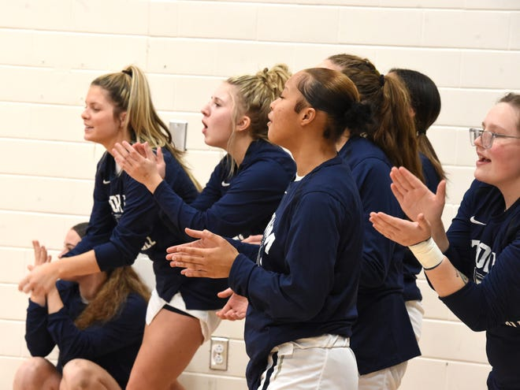
Payne has also studied some of the great basketball coaches. John Wooden, the legendary UCLA coach, said one time that the in his first practice every season he taught players how to properly put on their socks.
If there are wrinkles around the little toe or the heels, that could cause blisters. It seems like a minor detail, but it’s important.
Payne gets frustrated sometimes when his players don’t pay attention in practice. By this point in the season, Payne doesn’t want to keep reminding players of the basics. They should know them.
Staunton has one game this week, against Buffalo Gap, and one game next week, at Alleghany County. Then, once winter break is over, the calm is over and chaos begins. Staunton plays three games the first week of January.
“It’s going to be very, very important to play attention to detail,” Payne said.
Staunton got the win Wednesday, 52-39, its second of the season. It’s now 2-3 heading into district play. Witt finished with 34 points. Kellsye Miller added seven, and Kourlyn Stewart finished with six. Maybe not the team's best effort, but a win is a win is a win.
There was a minor discipline situation that Payne addressed before the game. He juggled the lineup because of it, which had two results. It caused a few struggles early with some different players on the floor, but it also gave some younger players, ones who hadn’t seen as much playing time, valuable minutes.
“They got a chance to see what they have to work on to get better,” Payne said of his younger players. “And the other girls got a chance to understand that they have got to pay attention to detail. It’s the little things.”
That’s what Payne is trying to teach. In the weeks to come, he’ll see how well they learn that lesson.

Holiday socks, a birthday basket and a district win for Staunton — Brewing the Storm bonus
Patrick Hite
Staunton News Leader
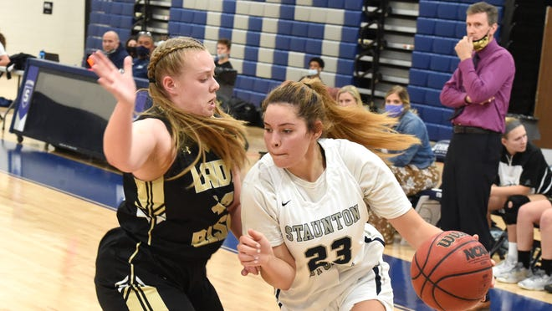
STAUNTON — Coach Eric Payne gathered his team in the locker room after Tuesday night's game and told them three things — "Good effort," "Way to run and play our style of basketball," and "Merry Christmas."
That last one was greeted by a joyous response from his players as they echoed their coach with a shout of "Merry Christmas."
It was the way the team wanted to head into the holiday break, a win that Staunton controlled from start to finish as it opened its Shenandoah District schedule with a 64-37 win over Buffalo Gap.
Staunton is now 3-3 on the season with a five-day break before resuming practice on Monday. Payne said family is important and he wanted to give his players time off over Christmas to spend it with their loved ones.
One of the areas of emphasis Tuesday, according to Kourtlyn Stewart, was to use speed to their advantage. They did that with a lot of early transition points off turnovers as Staunton opened a 25-7 first quarter lead.
"I was a little more confident shooting the ball," said Stewart, who finished with eight points, including a pair of buckets in the first quarter to help the team grab the big lead.
Emma Witt led Staunton with 27 points. Freshman Sam Swift finished with nine points, while Sara Lotts and Kellsye Miller had seven each.
Nevaeh Henson and Mia Neely rounded out the scoring for Staunton with three points each. Neely, celebrating her 17th birthday, hit a 3-point bucket with 6:17 left in the game that gave Staunton a 53-25 lead,
"This is a good ending," Neely said. "I'm going to go eat."
The plan was a trip to Cookout to celebrate her birthday with Stewart after they left the gym.
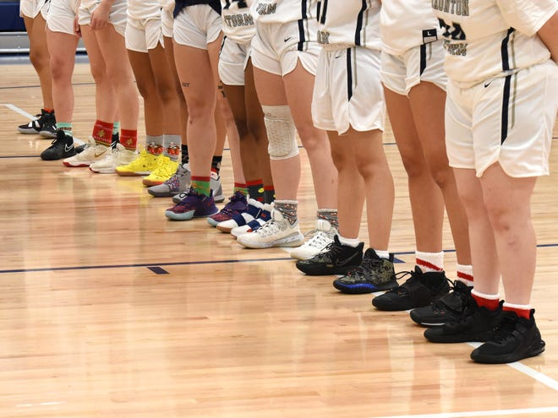
The team also celebrated Christmas by wearing holiday-themed socks during the game. After their performance, maybe they should break them out again after Christmas.
Payne said his team executed the game plan very well Tuesday. He was also thrilled with the effort of his bench players, saying they played hard when they got their chance. Assistant coach Jamie Taylor told the players in the locker room that those non-starters showed the coaching staff "a little something," in the win.
"Good job to the second squad," Taylor said.
Everybody played, with all 11 players getting minutes Tuesday. They've all worked hard in practice and it showed during the game.
Payne said a year ago his Storm team struggled playing with a lead. Tuesday night that wasn't the case. Staunton led by 18 after a quarter, 19 at halftime, and 22 after three quarters before winning by 27.
"They're learning how to win ballgames," Payne said.
Lotts said a district win made Tuesday night even more special.
"It feels like we all came together as a team," the senior said.
— Patrick Hite is The News Leader's education and sports reporter. Story ideas and tips always welcome. Contact Patrick (he/him/his) at phite@newsleader.com and follow him on Twitter @Patrick_Hite. Subscribe to us at newsleader.com.

