Sports Rath: A seasonal wrap up for the Petersburg Crimson Wave; it's not where you start, it's how you finish
Zoe Collins RathThe Progress-Index
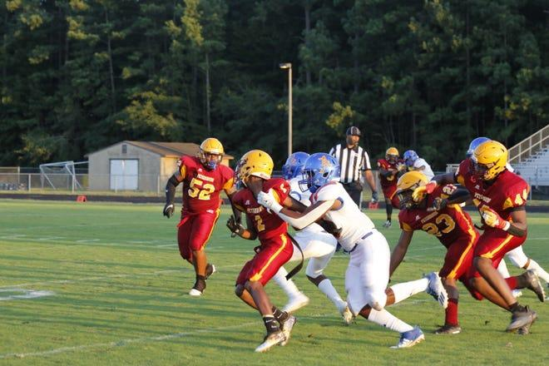
Another COVID-19 season is in the books for the Petersburg Crimson Wave and while they finished 2-7 it was a season of resilience, adjustments, and growth.
Like other teams in the conference, they had games changed due to things outside of their control. Early in the season, they played two games in five days because of COVID-19 rescheduling, but it didn’t stop there. Two teams canceled games because of high COVID numbers making the transition from one part of the season harder because not playing different opponents for two weeks made the Wave a little rust.
They had moments of great joy because they got to play with each other. Who could forget against Thomas Dale that Keith Young, outside lineman, and linebacker, caught a deflected ball and had to be brought down by three defenders after he ran for the first down?
While what is considered a losing season, finishing 2-6, leaves many questions about the team, which will be answered in the fall. As the song goes from the musical Seesaw:
It’s not where you start, it’s where you finish.
It’s not where you go, it’s how you land.
At the beginning of the season Head Coach, Mike Scott said they are “one year away from being really good”. The junior heavy-squad of this season will become more refined and will put in work to reach their potential.
The soon-to-be seniors will play the same teams and they know what to expect from them. Knowing who the teams are and what they do, can influence how they prepare for the fall 2022 football season.
Having that experience and as a team that leads each other, the Wave will capitalize on what they already have. But they will grow in the areas throughout the season that made people think, “next year will be a good team.”
Thought the season the Wave stood to battle other teams who were bigger and had more numbers than them. Even though they lost those games, players were there to lead the team and show what the Wave is capable of.
“I was extremely proud of the effort our kids gave Friday night…,” said Scott.
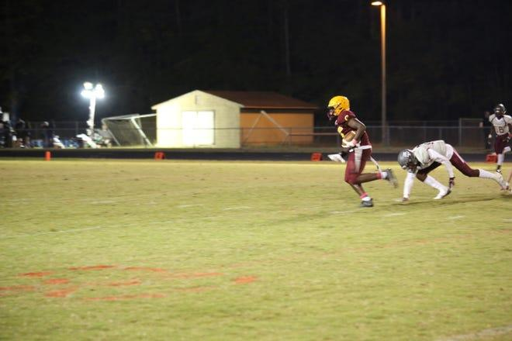
Against Prince George, Donnell Batts is a versatile player. When senior running back Jonathan Bolden had an opening to score, Batts was there to block a Royal and created the space for the Wave to score. Batts was able to have moments like this throughout the season and with the power he has to plow through people he will be a great offensive threat for the Wave.
Zahmarie White-Muhammad will be another offensive threat. The wide receiver was an offensive threat downfield in the earlier part of the season because teams could not stop him. White-Muhammad is a tall, quick receiver with hands that can catch anything and it is difficult to utilize him when the opponent's cornerbacks and safety can take him away as a downfield option.
Yet, he does the same thing for other teams. Against Thomas Dale, White- Muhammad was making stops to stop runners and made incomplete passing plays to stop the offense for the time being. Even though he was not the main option like he previously was, he landed in a great position on defense.
“Our aim is to improve the offense… in points per game and points allowed per game,” Scott said.
The Wave has grown in its ability to start strong and put up more points as the season went on. They took the lead at the half against Colonial Heights and until fatigue set in against Prince George they had a chance to put the game away.
While their offense struggled to convert on downs, it was their defense that was able to keep them in games for as long as they could. Or, at least stop the bleeding. The Wave refused to go by not playing and doing all they could.
They have all the right pieces to make something special next season, especially on. If Kelvontay Carson, the junior quarterback, can stay healthy. Carson can make big throws downfield that Batts, White-Muhammad and Rayjuan Traynham can make.
He played as best he could in the final games but had to leave against Prince George due to injury. Carson went out of the game crying his eyes out because he wished he could have done more. Staying healthy can be a big difference for the offense and how he lands from an unfinished season this year.
Petersburg knows what their offense can do and their defense has the potential to be better than this season. Traynham is a gritty player who can close on a receiver and close on them as seen in the game against Dinwiddie.
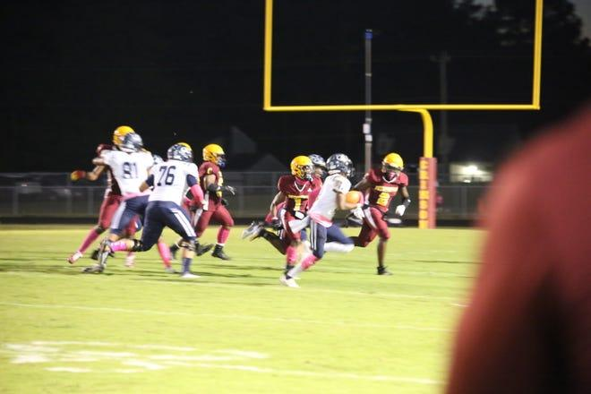
The Crimson Wave has moments of great potential and what they can do because they have the right tools to make something happen for themselves. With a 2-6 record their season comes to an end but this is the time to put in work.
The Wave has the effort to make something work and to the very end did not give up on themselves. With all the adversity and all the hard game losses, it could be easy for a team to run through the motions of a game to end the season sooner. But the Wave still showed moments of wanting to win because they believed they could, even if they only won two games.
It’s not how you go.
It’s how you land.
Zoe Collins Rath (she/her/hers) is a sports and education reporter for the Progress-Index. For times email her at ZCollinsRath@gannett.com or follow her on Twitter @zoe_jordan99.

Crimson Wave drowns John Marshall in a 62-6 victory at home, 2-1 on the season
Zoe Collins RathThe Progress-Index
Petersburg Crimson Wave crashed and made a splash against John Marshall Friday night at home with a 62-6 victory.
Coming off a hard loss last week against Booker T. Washington, the Wave worked things out with their second and third stringers to be prepared for this game. Players have been out due to injuries and isolation from cases of COVID-19 at school, but the Wave played like everyone was healthy.
"Each victory that we get, we're going to appreciate it because we know it's gonna be hard to get them," said Head Coach Mike Scott.
Since the Wave started on defense they tossed around the John Marshall offense, forcing them to punt and the Wave offense to start on their own 30-yard line. Senior, running back Jonathan Bolden saw the open field after a hand-off and did not stop running until he reached the endzone to make it 7-0. Bolden’s quickness and second-effort rushes would be impossible to stop.
After the defense had a quick break they took over and did not stop putting on the pressure. They forced the Justices to use every offensive asset available but it was no use as the Wave swarmed them. The Wave did not have the defensive players they typically have yet help defense kept John Marshall at bay; it would be that way the entire game.
But the offense was firing on all cylinders and senior running back Jonathan Bolden was leading the charge. He would have 136 yards rushing in the first half and would get the Wave in scoring position as the first quarter came to a close.
Continuing his success, Bolden ran the ball up the middle for his second touchdown of the night; his third overall. Scott decided to do something different this game for the extra point. Instead of missing the kick, the Wave has missed nine total this season, to try a two-point conversion. Junior running back Rayjuan Traynham was able to run the ball in to make the score 15-0.
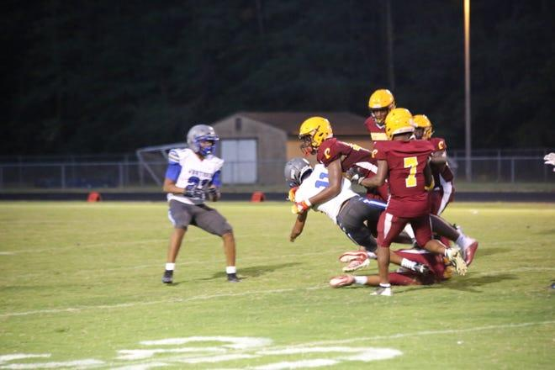
“They [the offense] tried to put the game away early so we can start trying to work on some things,” said Head Coach Mike Scott.
But the quick drives were short-lived as the second quarter continued. The defense did their job but to force turnovers. Junior lineman Donnell Batts was able to read the offense of John Marshall and broke a trick play to sack the quarterback Jaevion Trent, forcing a John Marshall punt.
Now back on offense, the Wave showed signs that they were playing sloppy and making mistakes not typical of them in previous games. Penalties nulled efforts of rushers Bolden and junior wide receiver Jamonta Chavis. Holding from the lineman would send the players back to the start. Bolden would rush 20 yards, yet an unsportsmanlike conduct penalty would send them back to the line of scrimmage. Other holding calls would cancel a touchdown run from Bolden, twice. Finally, in the final seconds of the game, Bolden was able to make contact with the endzone without a flag flying and have his final touchdown of the night to take half.
At the start of the second half, the Petersburg offense did not stop its momentum. With the opening drive, Traynham was able to work the offense easily into John Marshall territory with an easy run. He was able to score a touchdown with ease but the two-point conversion was proven difficult because of back-to-back offside penalties for the Justices. Finally, the score was 31-0.
But the Justices fired back with an easy touchdown run and they missed their extra point. There was a gap in coverage that was not covered by the Wave secondary. That would be the only time John Marshall would see the endzone as an offense.
Quarterback Joseph Shuford was leading the offense since all quarterbacks for Petersburg cannot play. But he was able to do a good job with it being his first week and him being able to bob and weave for a 64-yard touchdown run to make it 37-6 showed how relaxed he was.
“Joe has been doing a good job since he came in here and trying to find a rhythm...it's tough to do and eventually, we found a rhythm,” he said.
Everyone on offense was involved in the scoring. Donnell Batts, a junior wide receiver was able to extend the Wave lead 43-6. The defense did their job by forcing turnovers and three-and-outs, so the offense could continue their touchdown train. But the defense did not want to be left out from the scoring. Junior defensive end Romawn Noel earned himself a pick-six to make it 50-7.
I'm proud of the defense, really, because we're better than we were in the spring," Scott said.
Junior Zahmarie White-Muhammad was quiet for the last few games. He can easily get open on routes but he has not reached the endzone for a while. But with five minutes left in the game, he ducked and weaved away from defenders for a 24-yard touchdown run to extend the lead to 56-6.
The defense still did its job and put more pressure on the Justices as time wound down. Junior defensive back Conye Jackson wanted to see the endzone and wanted to prove to the John Marshall crowd that he wasn’t scared of them. With his heads-up defense, a loose ball found its way to Jackson and he broke tackles to see the endzone to make the final score of 62-6.
The next time the Crimson Wave takes the field will be next Friday, Sept. 24 against Hopewell High School.
Zoe Collins Rath (she/her/hers) is a sports and education reporter for the Progress-Index. For times email her at ZCollinsRath@gannett.com or follow her on Twitter @zoe_jordan99.

He may be 'small in stature' but gets big results for the Crimson Wave against Meadowbrook
Zoe Collins RathThe Progress-Index
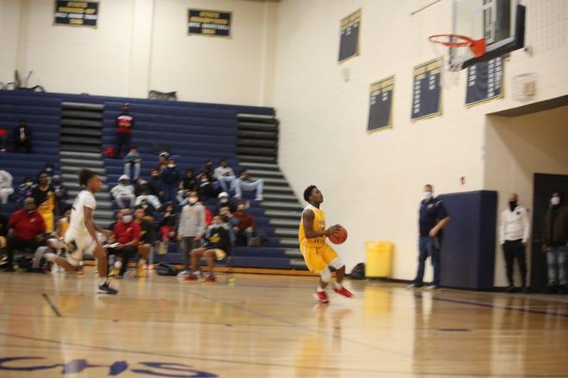
It was the third quarter and Meadowbrook was hot on the heels of the Petersburg Crimson Wave with their fire shooting; someone had to get the Wave a turnover in their halfcourt press to put away the Monarchs.
The positions that generate the most turnovers in the Petersburg press are for the quick and lanky players on the Crimson Wave such as Jamari Garnett, Bernard Fuller, Kaymeign Lundy, Tylik Lawerence, and CJ Claiborne. The position forces turnovers and allows scoring in transition.
The Wave had some issues with fouls that game; so in comes George Wilson III.
Wilson is a senior that gets minutes every so often to relieve the main ball handlers and replace them in the trap. The trap can be broken by successful skip passes around the court.
A Meadowbrook guard passed the halfcourt line and was looking for a skip pass but Wilson leaped for the interception. Once he touched down again, there was nothing but the open court in front of him. But the Wave did not score due to a few passes too many. But that did not stop him.
"Coach told us the key to winning this game as getting at those guys defensively," said George Wilson III
Another Monarch made a mistake on offense. They picked up their dribble and Wilson pounced. Stripping the ball he was able to score an easy layup to extend Petersburg's lead.
"He's small in stature, but he can be a pest on defense," said Head Coach Ryan Massenburg said.
Wilson had one of his better games for the Crimson Wave in their 73-51 victory over Meadowbrook because of Wilson's ability to generate turnovers and score. Petersburg has a deep bench that can make plays and Wilson's performance demonstrated that depth.
He had four turnovers and scored six points.
"He probably had the best game he had all year," Massenburg explained.
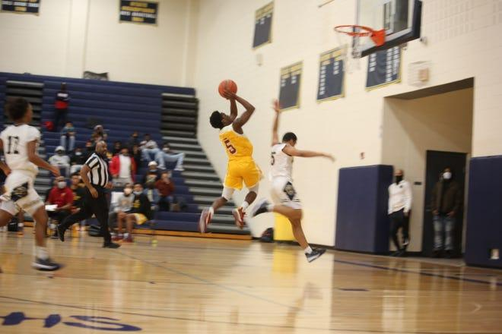
Massenburg said that the coaching staff has been on Wilson since the first day of practice because of how fast he is on the team. In order to get the best out of him, Massenburg would always tell Wison to use his quickness.
"Coach Massenburg usually gives me the green light to gamble for steals because I am so fast," Wilson explained.
The steals did pay off since he was leaping for lobs and swiping steals on dead balls. Both he and his teammates were able to score in transition for the Wave to extend the lead as the game was almost over, especially since the third quarter was critical.
The game was within nine points when the third quarter started and while the Petersburg offense was generating points, Meadowbrook was creeping back in because they were heating up from the field.
In comes Wilson who was able to facilitate opportunities for scoring for his teammates. A game like tonight was a boost of confidence for the senior who wants to contribute in any way he can to help the team achieve their goals.
"My confidence is high right now knowing I can bring something to the table to help reach our long-term goal as a team," Wilson said.
Petersburg's record was extended to 7-3 with the win. Prince George is next and they will pose as a challenge for the Wave due to Royal's victory in the Tri-City Holiday Tournament.
However, Wilson's performance was able to demonstrate that Massenburg can call on anyone to make an impact for the Wave. If one of the shortest players can energize the bench by being a pest on defense and having moments of being a playmaker for his team, then so be it.
Four steals in a quarter is a big deal for someone coming off the bench. But Wilson reminded the gym that it's not about size, but about using their skills to the team's advantage. Wilson brought the speed and turnover rate, for Petersburg to win.
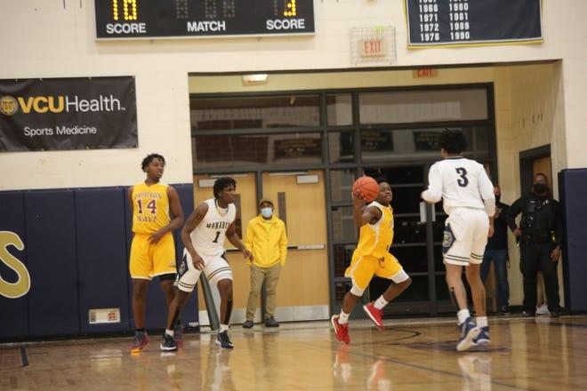
"He [Wilson] was he was big sparkler for us tonight," concluded Massenburg
Zoe Collins Rath (she/her/hers) is a sports and education reporter for the Progress-Index. For times email her at ZCollinsRath@gannett.com or follow her on Twitter @zoe_jordan99.

