Two reporters arrested, released, during Andrew Brown Jr. protests in Elizabeth City Wednesday night
Sophie Blaylock, Jeff Schwaner
Staunton News Leader

Two News Leader reporters were arrested Wednesday night in Elizabeth City, N.C. while covering a protest.
The arrests occurred after hours of protests over the recent announcement that Andrew Brown Jr.'s killing by sheriff's deputies was justified and that deputies involved would not be charged.
Ayano Nagaishi and Alison Cutler were filming an arrest from across the street when police approached them, asking for the "ladies in the vests."
They were wearing their media vests and they repeatedly identified as media as they were being cuffed.
​Cutler asked what the charges were and the officer replied, "For standing in the street in a roadway."
A citizen filmed the arrest with Nagaishi's phone, which an officer then retrieved and placed in her pocket.
Cutler was able to call from a police van and confirm they'd been arrested, along with at least 4 other people. Her phone was confiscated after another person in the police van tried to livestream.
The arrests happened about five minutes after police and the protesters dispersed from a tense scene on a larger main street shortly before 9:00 p.m. Police threatened to arrest protesters for a law that prohibits, according to their announcement, standing, sitting or lying on a street or roadway.
​Protesters walked several blocks on the sidewalk and came to a street where two white police inmate transport buses were parked. Those buses had additional police inside.
​After protesters started to walk in circles at that intersection, using the crosswalks to keep their movements legal, more police moved in.
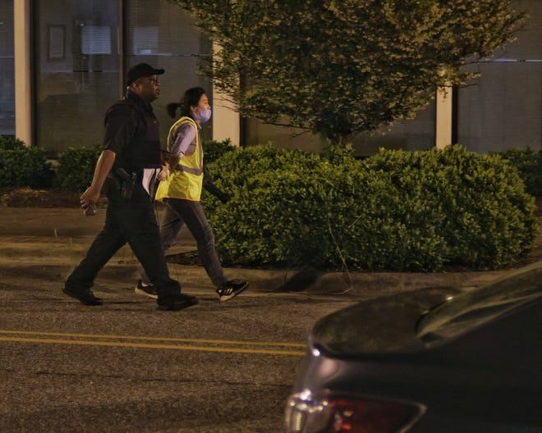
Nagaishi and Cutler said after their release they were no more than a foot away from the curb, in a crosswalk, when filming the scene across the street. It's unclear whether either will be charged.
The reporters were released at 10:30 p.m.

Spring of reckoning: Public art increases in Carolina city that can't sleep after killing
Ayano NagaishiAlison Cutler
Staunton News Leader
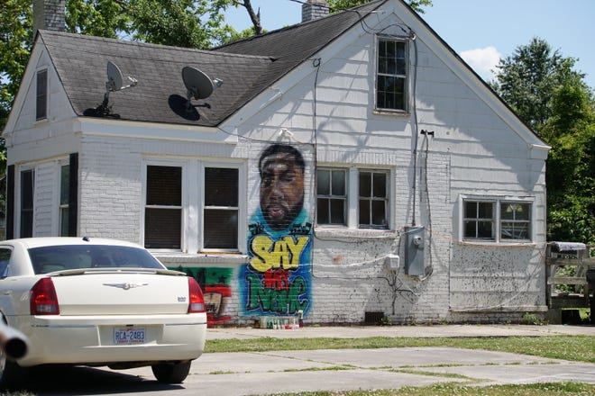
ELIZABETH CITY, NORTH CAROLINA — The hands of Ulysses Edwards were dirty, blackened with paint when he heard the chants down the road in the neighborhood.
"Say his name! Andrew Brown! Andrew Brown!"
It sent chills down his spine. He stood on a ladder tilted against the side of the wall of the house where his friend had been fatally shot by a truckload of police the week before.
Edwards had begun sketching out Brown Jr.'s face and adding base shading to the mural. Edwards paints murals for a living and runs his own tattoo shop in Elizabeth City, a rural North Carolina spot that has been grappling with the same issues of race and police brutality that are playing out across America.
It's not a town that expected this to happen. It wasn't ready. Would a quiet, out-of-the way town like this ever be ready? It's the South, though. Legacies of violence against Black citizens are long. And so are questions about police.
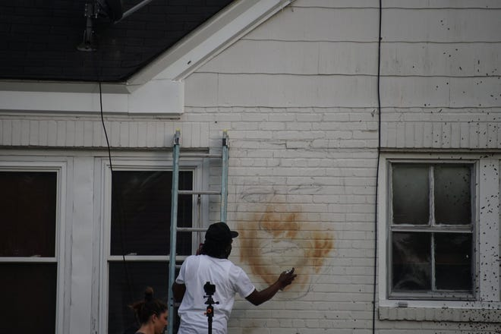
It's been a month since Brown Jr. was killed — and Elizabeth City has been forced to answer some of those questions, even if not in official channels. It is playing out partly on the streets, as dedicated protesters show up night after sleepless night.
It also has appeared in the public discourse and grassroots projects.
This time, it was about a friend commemorating a man who had been shot in the back of the head just yards away from where he stood.
When he heard the crowd down the street, it all became more real.
"You already know why you’re here but when you see it ... it was very emotionally overwhelming," he said.

'This is serious and I want to capture that'
As people keep protesting night after night, Edwards is making progress on his mural.
There is a shine in Brown's eye on the wall.
His face isn't smiling. It is stoic, distant.
"The mural should tell a story. This is serious and I want to capture that," Edwards said.
Next to his mural, the white wall is spattered with mud that was sprayed all over the side of the house from Brown Jr.’s tires on the day he died. His vehicle left tire tracks deep in the lawn next to the driveway.
The mud flecks direct the viewer's eye to the mural — an effect Edwards thought about when he started airbrushing.
His mural is now one of many across Elizabeth City, works of art that double as stories and powerful statements about the core nature of the town and the people who live in it. They represent the beauty of the community, but also its continuing pain and shock after a death many feel was senseless.
Before the shooting, Edwards said, he used to brag about the peacefulness of Elizabeth City and the good relationship between the police and the people. Now, there’s a sense of uneasiness that he doesn’t want to have to experience when it comes to the police.
“In my heart, (the police) are my security. You should make me feel safe,” he said. “I shouldn’t feel scared.”
Edwards has spent a lot of time at the lot where Brown Jr was shot, even when he isn’t working on the mural. One night he came to remember Brown at the memorial site at 3 a.m.
He was nervous when he saw a police car parked in the dead of night right next to the memorial, but a white female cop and a black male cop came out to speak to him and complimented the memorial.
Night after night, Edwards says, people are coming to pay their respects.
He turned around to face his portrait of his old friend.
“The community can’t sleep,” he said.

Centuries of culture
Every day when Colleen Brown makes her way to work at the Arts of Albemarle gallery downtown, street murals demand her attention.
“Public art is exploding,” Brown said. “You want the space in which you live to represent you, your values and your voice.”
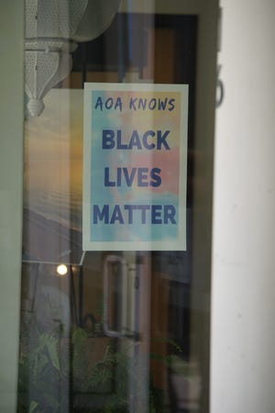
The Arts of Albemarle has worked with local artists to promote street art and Brown is part of a committee that is interested in creating a series of murals celebrating African American history in Elizabeth City — a line of history that reaches deep into the past of the town.
A hundred and fifty years ago, the same streets Brown and the rest of the residents walked down looked entirely different. It wasn’t decorated with street murals or protests for justice. The alleys were filled with sailors, soldiers from the Civil War and fishermen.
It was later declared “The Harbor of Hospitality” on the city’s official seal. The local museum exhibits a collection of dozens of different artifacts extracted from the Pasquotank River, which runs just across the street from the display.
Wanda Lassiter, curator at the Museum of the Albemarle, said that the two main industries that the city was built upon continue to be relevant to Elizabeth City today.
“Maritime plays a heavy role because this area was half land and half water. You had and still have a big fishing industry, but heavy agriculture as well,” Lassiter said.
The museum commemorates the city’s local legends of pirates in the harbor, the importance of pigs and hogs as food throughout the region and how the Civil Rights Era sounded through the small town. In 1962, Martin Luther King Jr. visited Elizabeth City to speak with the local civil rights movement.
The establishment of a US Coast Guard Base drew servicemen and government contractors. It now harbors three institutions of higher education — the Elizabeth State University, Mid-Atlantic Christian University and the College of the Albemarle.
The presence of universities has lent even more artistic displays to the town. The Arts of Albemarle gallery has a room dedicated to artwork by students from Elizabeth City State University.
The student section of the gallery has different themes, including minimalistic memories of COVID-19. Another piece of art from a student was titled CAUGHT. It depicted a Black man in chains standing for a mugshot.
“Anytime you create any art at all, it is a self portrait,” Brown said, gesturing to the art in the gallery. “But when it’s public art, it’s a self portrait of the community.”
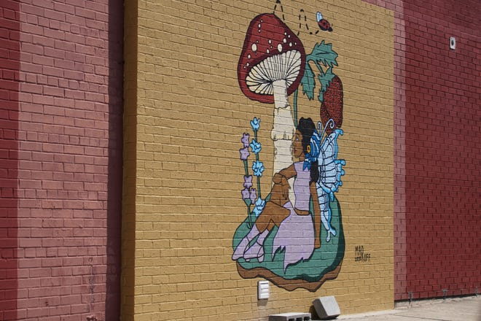
Brown is enthusiastic about the swell in street art in Elizabeth City. Her office is tucked away among hundreds of paintings from local artists that are displayed in a traditionally sleek gallery. Some locals focused on beach landscapes, flowers and dramatic self portraits.
When artists decide to move from painting or working privately to showcasing their work in a gallery, it’s a big step in the process of sharing their work and expression with other people, Brown said, but even galleries aren’t entirely public. They still require someone to walk through the door, which is why the act of public art is so intentional.
“The impulse to create art that is 100 percent public, that’s an even greater step. That’s a breaking point, in a good way,” she said.
Brown said that nowadays, the community uses murals and street art, much like the portrait of Andrew Brown Jr., to send a message to the community and other audiences.
To the left of Brown Jr.’s face on the mural was his name as well as three words. “Say his name.”
For many members of the community, it’s a memorial to honor Brown Jr. It’s also a message to those involved — law enforcement.

Different faces of law enforcement
Cheryl Morrison has lived in Elizabeth City for over 25 years. She talked about the relationship between the police and community members of Elizabeth City. Morrison specified that people of Elizabeth City have actually had a good relationship with Elizabeth City Police Department.
Morrison spends most of her time at the senior center near the waterfront working out. Elizabeth City police officers would often come to the senior center and join the people for activities and more, she said.
“It’s not the police department. It’s the sheriff’s office. They are the problem,” Morrison said.
The Pasquotank County Sheriff’s deputies rode in to town on the back of a pickup truck with hats twisted backwards and rifles at the ready to arrest Andrew Brown Jr. in the incident that resulted in deputies firing multiple times through his moving vehicle. The relationship between the sheriff’s office and Elizabeth City has always been rocky, Morrison said, but it has gotten worse since Brown Jr.’s shooting.
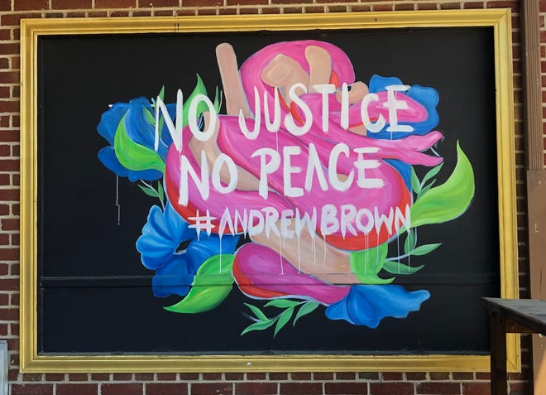
Elder David Lee grew up near and in Elizabeth City his entire childhood and when he heard of the shooting of Andrew Brown Jr, it reminded him of when his own father was murdered when he was just a child.
“The police just swept it right under the rug and called it self defense,” Lee said.
A statewide investigation announced on May 18 that the shooting of Andrew Brown Jr. was justified. Two deputies were put in threatening situations by Brown moving his car in an attempt to esdape, according to District Attorney Andrew Womble.
“It was horrible, seeing his car all shot up like that," Lee said. "I grew up without a father. I know how that feels. I never was able to know what happened to my father, but I pray that Browns’ children will.“

'Public art is becoming more important'
Dr. Evangelist Yolanda Cooper finds herself drawing and sketching to keep her mind busy. She never felt compelled to put out her work publicly, but she enjoys the street art around the community.
She sat in a rickety chair out in front of the Arts of the Albemarle, wearing a black t-shirt even though the afternoon was hot and humid. It read JUSTICE FOR ANDREW BROWN. Next to her on the door of the arts center was a sign that read “AOA KNOWS BLACK LIVES MATTER.”
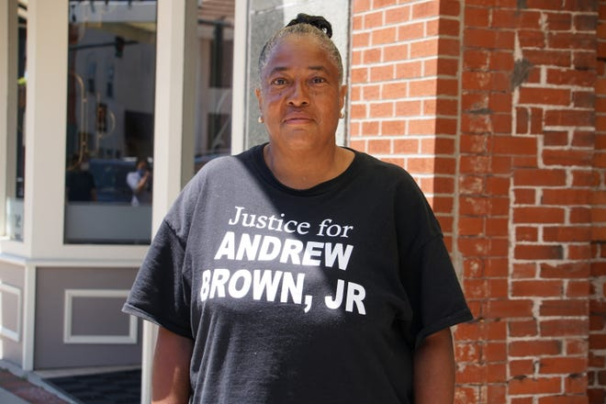
Cooper said that the portrait of Brown Jr. was the most beautiful one she has ever seen.
“In that mural, he’s not in pain, he’s not suffering. It’s a message of hope for the future, if we do the right thing.” Cooper said. “It shows there’s good in everybody.”
Residents who take to the streets at night to protest for the justice of Andrew Brown Jr. all experience different emotions when they see the mural. Some are angry, some find peace and others have sunk down to their knees in mourning.
There are artistic souls all across the city, Cooper said, and it's apparent on an abundance of blocks in the town - from brilliant murals of lighthouses and coastal wildlife.
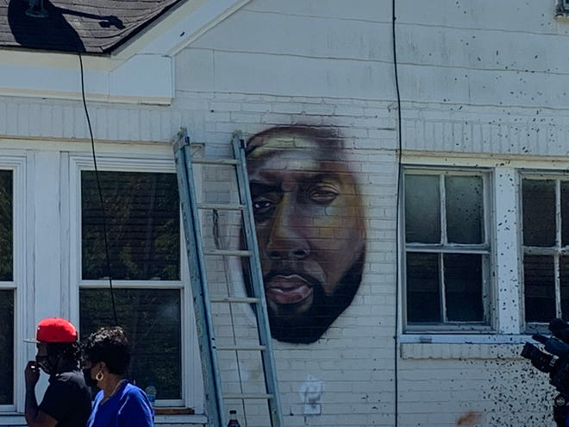
In Elizabeth City's history, art was hung simply in upper-class homes, or used as a substitute for money when a woman couldn’t pay her medical bills. Through time, the creative pulse seeped under the doors of the galleries and homes and into the sea-chilled air of the town. Now, more than two hundred years after the city’s inception, it has made its way onto battered brick walls, restaurants and even crime scenes.
“Public art is becoming more important culturally and people are paying attention,” Brown said. “It’s because outside we’re looking for the natural landscape but we’re also looking for something more.”
For the small city, street art has become a form of communication, tiny messages and themes tucked into alleys and curbsides for all the world to see.

