A four-month strike from the Barbers contracted to work at Fort Lee ended with their employer agreeing to their payment demands. The contractor has been in trouble with the national labor relations board before. The Progress-Index was the first outlet to cover the strike, it was later picked up by local news organizations.

'I don't want to have to leave': Fort Lee barbers strike over alleged unfair wage structure
Sean Jones
The Progress-Index
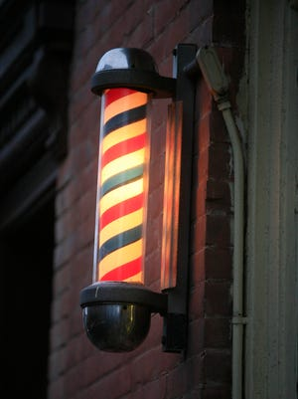
FORT LEE - Haircuts at Fort Lee are on hold after the base's barbers decided to go on strike earlier this week. Their allegations include claims that they are being underpaid by the contractor in charge of the base's three barbershops, plus one at Fort Pickett.
Around 20 barbers at the base are organized under a union. Those barbers initiated an Unfair Labor Practices strike earlier this week.
Mike Kates, 38, has been a barber at Fort Lee for the past 15 years. He said the pay structure put in place by Sheffield Barbers is costing him somewhere close to $1000 a month.
The pandemic was an especially difficult time for barbers. Stylists worked every other day to keep building occupancy at an acceptable level for social distancing. Kates said the pay structure is becoming untenable, and has him questioning his future at the base.
"I love my job and I love cutting hair at Fort Lee. I wanted to stay until I retire," Kates said. "When I got there 15 years ago, there were other people who had been there for 20 or 30 years. It's not like people come and go. Once you're there, you're there. I don't want to have to leave."
When Sheffield Barbers first took over, employees were earning 55% of the per haircut fee of $12.15. According to the barbers' union representative, Sheffield reduced that fee to 55% of $11.25, the haircut price charged in 2017. That means stylists are seeing almost one dollar less profit per haircut.
Since taking over, Sheffield has increased the price per haircut to $13. Kates says he is still earning 55% on a per cut price of $11.25 and that all of the profit is going toward the contractor.
When Kates first started working at Fort Lee, the price was around $7.50. He says he has always made 55% on every price increase until now.
Barbers can see anywhere between 40-60 clients per week, depending on the week and the barber.
Fort Lee's barbers are organized under LiUNA, a union for public service employees in Virginia, Maryland, North Carolina and Washington D.C. LiUNA also has membership from janitorial, food service and gas station employees at the base's post exchange.
The new barber pay structure was implemented immediately when Sheffield was awarded a contract by AAFES to run the shops. LiUNA finally reached negotiations with Sheffield two months ago in an attempt to increase the rate back to 55% of the total price per haircut. The union said that Sheffield agreed to a 6-cent increase per haircut, which was unacceptable.
"It's a [one-sided] change," said KC Doggette, a union representative. "I showed the intent of language that’s in the contract. I showed the movement as the price on the wall went up and they still refused to make those wages correct."
LiUNA is also alleging that Sheffield bypassed union authority and attempted to negotiate higher wages with two individual barbers. It also says that employees had $450 taken out of their paychecks to purchase vacuums, an item the contractor is fiscally responsible for purchasing.
Kates said that one of the two barbers accepted the higher pay. He also said both barbers were present at every union meeting and that both voted in favor of this week's strike.
Sheffield Barbers LLC is a Missouri-based business that oversees contracts at military bases across the country. In 2018 it had 134 employees across seven military bases.
The contractor has previously been charged with misconduct by the National Labor Relations Board.
In 2016, Sheffield was found to have rescinded a job offer to an employee at Joint Base Langley-Eustis in Hampton, Virginia because she engaged in union activities.
Then in 2017, the NLRB found that Sheffield engaged in unfair labor practices by refusing to recognize and bargain with a barbershop union at Nellis Airforce Base in Nevada.
The order said Sheffield engaged in "surveillance" of its employees, reduced commission rates and hours without consulting the union, changed employment terms and conditions without notifying the union, restricted employees from exercising their rights and fired or discriminated against employees who discussed these changes.
A message forwarded to managing members of Sheffield Barbers LLC was not returned by time of publication.
Doggette says the barbers at Fort Lee are prepared to strike for as long as it takes to reach the original 55% fee they have been paid historically.
You can reach Sean Jones at sjones@progress-index.com. Follow him at @SeanJones_PI. Follow The Progress-Index on Twitter at @ProgressIndex.

'I gave these people 110%:' Fort Lee barber strike continues, no word from contractor
Sean Jones
The Progress-Index
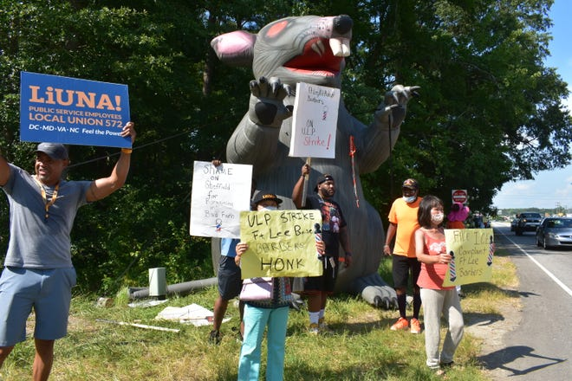
FORT LEE — Fifteen barbers got together to picket outside of the Sisisky Gate Friday. It had been twelve days since they started an unfair labor practices strike against Sheffield Barbers, and they were yet to hear anything from the contractor about meeting their demands.
They stood outside the gate on Oaklawn Boulevard with signs that read “on U.L.P strike,” “File I.C.E Complaint Ft Lee Barbers” and urging people to honk in support.
Seemingly every minute, a large truck driving past would take them up on the offer and lay on its horn for several seconds as it rolled past.
About 20 barbers organized under LiUNA Local Union 572 are striking against Sheffield Barbers for allegedly underpaying them. The barbers have historically made 55% of the sticker price for a haircut at the base’s three barber shops – plus one at Fort Pickett.
Barbers say that once Sheffield was awarded the contract for those facilities, it started giving barbers 55% of $11.25, the price from 2017, while at the same time increasing the actual cost for a haircut to $13.
One picketer, Matt Macklin, retired from the barber shop on base after working there for 48 years. He said he heard about the wage fiasco when he was at a funeral. One of the other attendees say they would be picketing and asked if he wanted to join.
“I said, 'That’s it, I’m going to be there,'” Macklin said.
Throughout his decades of cutting hair, Macklin came to know his fellow barbers as family. Often times you would stand next to the same barber for 16 years. It’s a barber shop that is known for its longevity. Once a barber is there, they usually work there for life. He wanted to show support for the institution he came to love.
“I don’t like the way they’re treating these guys,” Macklin said.
Many of the barbers at the base’s shops have been civilians their entire lives, but Eugene Harris served for 21 years before becoming a barber. He is a retired Motor Sargeant, and was deployed to Iraq and Kuwait before ending his military career.
“I understand the importance of appearance,” Harris said. “When soldiers come in, they want to look presentable because their jobs depend on that. I know what a soldier is supposed to look like, I know what a soldier isn’t supposed to look like.”
Army Regulation 670-1 sets the standard for army uniform and appearance, including grooming policies.
Ar670-1 says that soldiers should take pride in their appearance. While many hairstyles are allowed, they must be “neat and conservative,” per the regulation. Male haircuts cannot drop below the eyebrows or touch the collar. Longer female hairstyles must be fastened above the lower edge of the collar and also avoid dropping below the eyebrows.
One specific line addresses hair that doesn’t part naturally. The regulation says that soldier with this type of hair can style their hair with only one part and that it has to be a completely straight line.
These are standards that Harris says he is intimately familiar with, and can ensure that soldiers at the base are adhered to.
Since Sheffield Barbers first got their contract just before the COVID-19 pandemic shut down shops across the country, Harris said that many of their customers have been aware that their barbers’ pay situation, which puts them in an awkward position.
“It’s kind of hard because it makes customers want to tip more, and they shouldn’t have to make up for what the contractor isn’t doing,” Harris said. “They try to compensate for that. It’s not fair to put that on soldiers, they don’t make much money in the first place.”
The barbers are arguing that the increased haircut prices, mixed with their decrease in pay means the contractor is pocketing a sum of extra cash rather than focusing the revenue on its people. One customer says that is a huge mistake.
Kevin Philips is retired army veteran who has been working and getting his hair cut at Fort Lee for the past six years. He says he won’t go back to the shop at Fort Lee until the dispute is settled in favor of the barbers.
“I even called the contractor to express the relationship that we have,” Philips said. “I’m just not willing to go back there and start all over with someone else at this particular point.”
That relationship is what he says he will miss most of the base’s barbers don’t have their demands met, and decide to leave.
“A barber is a stylist; they know what you want. You don’t have to explain how you want your cut. But you also establish a personal relationship with them as well. I know about his family, he knows about mine,” Philips said.
Now in management for an agency at the base, Philips added that losing these barbers would be a terrible mistak because they’ve become an institution, with a number of barbers that are longtime employees.
“People think you can just slide one thing in and slide it out. It takes a whole rebuilding process. In my mind, [Sheffield] is doing [itself] a disservice because the barbers have a known product that has been producing for years,” Philips said. “I don’t think they see that loss, it’s going to be a loss.”
Currently, temporary barbers have been hired in the place of those that are going on strike. Sheffield Barbers is also advertising for barbers on Indeed.com. The listing says it is seeking 8-10 people and offering a pay rate of “up to” $70 and hour. The barbers say that is well above the compensation they are asking for.
While striking, many barbers have been going completely without a paycheck. One barber, Mike Kates, has been cutting hair for many of his former clients while also advertising for more customers on social media to help make ends meet. Kates said it feels like a waiting game, with Sheffield just waiting to see how long the strike is going to last.
One of the base’s newer barbers, Delvon Jackon, is one of the barbers going without a paycheck. He said unless the pay is reinstated to 55% of the sticker price, he won’t go back to work at Fort Lee.
“I gave these people 110% and it only makes sense that you would treat your employees right,” Jackson said.
You can reach Sean Jones at sjones@progress-index.com. Follow him at @SeanJones_PI. Follow The Progress-Index on Twitter at @ProgressIndex.

Sheffield Barbers says it is offering 'fair wages' amid an ongoing strike at its Fort Lee shops
Sean Jones
The Progress-Index
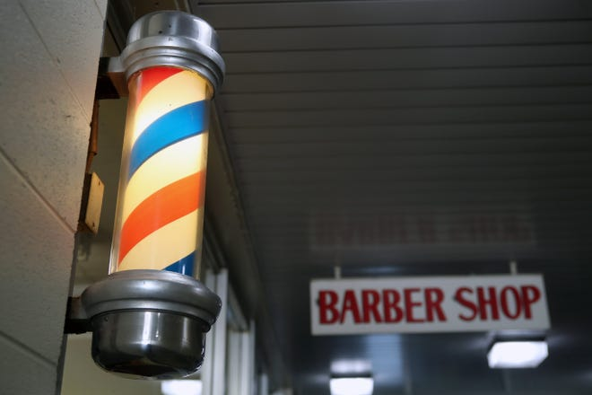
FORT LEE - You may have seen the giant inflatable rat outside of the Sisisky Gate on Oaklawn Boulevard. The people standing around it are picketing Fort Lee's three barber shops, alleging that the contractor in charge of operations is underpaying them.
The barbers say that when Sheffield Barbers took over the shops at Fort Lee and one at Fort Pickett, their pay was immediately reduced. Sheffield took over shortly before the pandemic.
The barbers' pay was reduced from 55% of each $12.15 haircut, to 55% of $11.25 - the price per haircut from 2017. All the while, they say the price of a haircut was increased to $13, but their pay rate has not moved.
Sheffield Barbers issued a statement Tuesday morning in which it says the striking stylists are engaging in misinformation.
"These allegations are simply not true," said Christina Deardeuff, a co-owner for Sheffield Barbers. "Sheffield Barbers is paying and has always paid the barbers consistent with the plain language of the collective bargaining agreement negotiated between LIUNA and the company that ran the barber shops before Sheffield took over."
By its estimate, Sheffield's barbers at Fort Lee averaged $22.48 per hour before tips in the six-week period before the strike. They estimate that with tips, the average barber was making about $35.32 per hour, with the highest earner making $59.56 per hour.
"Despite these very fair wages, at the time LIUNA went on strike, Sheffield had proposed a wage increase for the barbers," Dearduff said in the statement. "However, LIUNA demanded more even after it was shown that its wage demands would put Sheffield in the red for its Ft. Lee and Ft. Pickett operations."
Sheffield claims that LIUNA has yet to appeal the National Labor Relations Board or pursue grievance under the collective bargaining agreement.
The contractor also said that it has shown "time and time again that it cares for workers," having paid its employees full salaries for eight weeks while shut down by COVID-19. The Missouri-based company did receive over $1 million in Paycheck Protection Program loans, nearly all of which was forgiven by the government.
Also said it has now filed an unfair labor practice charge against LiUNA for "making unlawful threats and unlawfully intimidating the employees who are coming to work."

Just how much does a barber make in the area?
Candise Nicholas owns ALBC School of Barbering and Cosmetology in Petersburg with her husband. The school teaches barbering and cosmetology techniques, as well as Business, Project Management and Cost Studies skills to its students.
Nichols says that the average men's haircut in the Tri-Cities can cost anywhere between $25 to $35. Unlike barbers at Fort Lee, most private barbers will make 100% of that amount, rather than 55% of a fee. However, private barbers have larger overhead costs. They typically have to rent their spaces and pay for all of their tools themselves.
Nichols says that a typical private barber can finish about one head every 30-40 minutes, eventually coming out to somewhere around $40 per hour. That includes when times are slower, and busier based on the day.
Despite the price of a haircut being lower at Fort Lee, barbers on base are known for their speed, being able to push out 40 to 50 heads per day.

LIUNA points the finger back at Sheffield for misinformation
Union representative, KC Doggette, says that no matter what rate Sheffield is offering, it still decreased workers' pay from where it was under the previous contractor when it took over.
He says it has everything to do with the contractor's "interpretation" of the contract for the business. Wording for the document carries over when a new
"It's not consistent, they're just trying to interpret the language to say they will give 55% of the posted price starting [at the 2017] date, and it will remain like that throughout the contract. That's just the start date," Doggette said.
LiUNA says it is false that they haven't attempted to go to the National Labor Relations Board. Doggette says he petitioned the governing body under the previous presidential regime. He said the NLRB wouldn't hear the barbers' case, saying the language in the contract was correct. That case has since been refiled with the NLRB, adding that the contractor made a "unilateral change" in the workers' pay.
The affidavit for that case was just submitted Tuesday, Aug. 3. The union should hear whether the Board will hear its case within the coming month.
LiUNA said it has yet to receive any charges filed against it by Sheffield Barbers as of Tuesday.
You can reach Sean Jones at sjones@progress-index.com. Follow him at @SeanJones_PI. Follow The Progress-Index on Twitter at @ProgressIndex.

Fort Lee barber strike ends after almost four months, contractor agrees to worker pay demands
Sean Jones
The Progress-Index
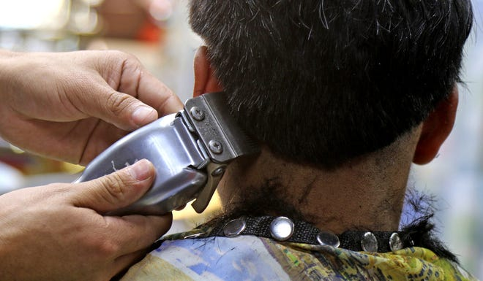
FORT LEE - The prolonged strike between barbers at Fort Lee and the contractor which employs them has finally come to its conclusion.
The Contractor, Missouri-based Sheffield Barbers LLC, has agreed to a new collective bargaining agreement that will reinstate the pay rate barbers were making before the contractor began managing the shops in 2019.
Barbers have historically made 53% of the price for each haircut. When Sheffield took over, it began paying barbers 53% for a cut costing $11.25, the price from 2017. Barbers made this rate as the price per haircut was increased to $13.25. The discrepancy reduced some barbers' wages by $1000 per month.
Under the new agreement, barbers will start earning 53% of the $13.25 posted price. If that price increases before 2025 those barbers will earn their percentage based on the increased price. This agreement went into effect on Oct. 25.
“We are not stuck with a wage from the past anymore, but a wage that will make for a better future,” said veteran and barber Eugene Harris.
About 20 barbers went on an unfair labor practice strike that started on July 4, after Sheffield Barbers made their last, best and final offer of a $0.06 increase per haircut. Elected officials and other labor unions have joined the barbers during their strike.
“Those extra dollars add up,” said barber Michael Kates II. “Staying on strike for so many months had its challenges. It was worth it, though, because now I’m earning a fair wage and I don’t have to leave a place that I love.”
The Army and Airforce Exchange Services awarded Sheffield Barbers the contract for the Fort Lee barbershops in 2019 and, due to the strike, Sheffield Barbers was in danger of losing the contract.
The barbers' strike was one of the first in a series of strikes happening across the country.
“We are seeing a nationwide surge of solidarity among workers, but I cannot say enough about the strength and solidarity of our barbers,” said Local 572 Business Manager Sonia Vasquez Luna. “No matter how tired they were or how hot it was, they were determined to win and they succeeded.”
Along with the barbers, Local 572 also represents janitorial, housekeeping, gas station, and food service employees on the base.
You can reach Sean Jones at sjones@progress-index.com. Follow him at @SeanJones_PI. Follow The Progress-Index on Twitter at @ProgressIndex.

