She’s in the next wave of police officers. How race and identity are changing the new generation of cops.

This graduating class in Staunton is at ground level for a behavioral pivot in law enforcement’s relationship with the community.
Ayano Nagaishi, Staunton News Leader
Published 10:47 PM EDT Mar. 22, 2021 Updated 12:02 PM EDT Mar. 23, 2021
“Elephant” and “Hawaiian Punch.” That was the extent of 9-year-old Natasha Marie Poventud Suarez’s English vocabulary when she moved to Virginia.
She didn’t need to know many words to see how law enforcement impacted America. In Puerto Rico, she saw virtually no law enforcement as she grew up. Police and English — they both fell into the same category for Suarez: foreign.
Her birthplace was as good as foreign to Virginians, too.
Puerto Rico is a U.S. territory, but Suarez said that once she moved to Shenandoah County, it was like moving to an entirely different country.
“People thought when I moved here that I had lived in a cave,” Suarez said. “They weren’t really sure where I was coming from.”
She saw that all eyes went to her family when they were in public. After coming from a place where everybody looked the same as her, she had to get used to being the odd one out.
Her family’s complexion turned heads at the store. It also seemed to magically turn on the blue lights of police cruisers, Suarez said. Her dad, who had darker skin than her mom, was stopped frequently on the road and asked about their destination. One time, he was questioned if Suarez was even his biological child.
Suarez felt small and hopeless in the back seat. The car window presented a harsh view of the realities of discrimination and threat.
“It was scary. You can’t help as a kid.”
Those types of interactions spurred some of her parent’s lectures about how to act around police: take it easy, no sudden movements, don’t do anything stupid.
Suarez’s experience with police differed from her parents’. As the law enforcement system stared her family down, she stared back — with curiosity and interest. Most of her positive encounters started in school, with on-campus resource officers. She began to see the profession as a field that serves people: protecting students on campus or civilians on the street.
As she started to feel at home and her English improved, she decided to become fluent in another language: the language of the law.
Suarez signed up to join the police force.
“I was kind of scared, but also wanted to learn why I was scared. I wanted to learn; how can I still be a part of that as a Hispanic woman?” she said.
Her parents didn’t oppose her decision to join the police force. Their main concern was her size. Suarez is far from the towering police figure of the public imagination. She is 5 feet, 2 inches tall on a good day and weighs 120 pounds. Still, they encouraged her. They said that she could do anything, regardless of race, size or gender.
Suarez was hired as a patrol deputy at the Shenandoah County Sheriff’s Office. Not everyone looks like her where she was recruited. More than 90% of Shenandoah County is white. Before she was able to get out into the field, she’d have to complete her certification.
Suarez is the future of police — in all its pride, transformation and trepidation. Her graduating class is at ground level for a behavioral pivot in law enforcement’s relationship with the community.

Trained to a T
First, they run.
Suarez’s feet hit the ground at 5 a.m. For the next 12 hours, she and the rest of her classmates at Central Shenandoah Criminal Justice Training Academy dedicate all they have to a tightly scheduled day — mind, body and spirit.
They flip tires, they do burpees and strain through push-ups. Fitness comes with a lesson the soon-to-be officers feel in the thrum of their bodies, with the sweat of their collective workout: In order to keep other people safe, they need to survive first.
“Being fit can save your life,” Suarez said.
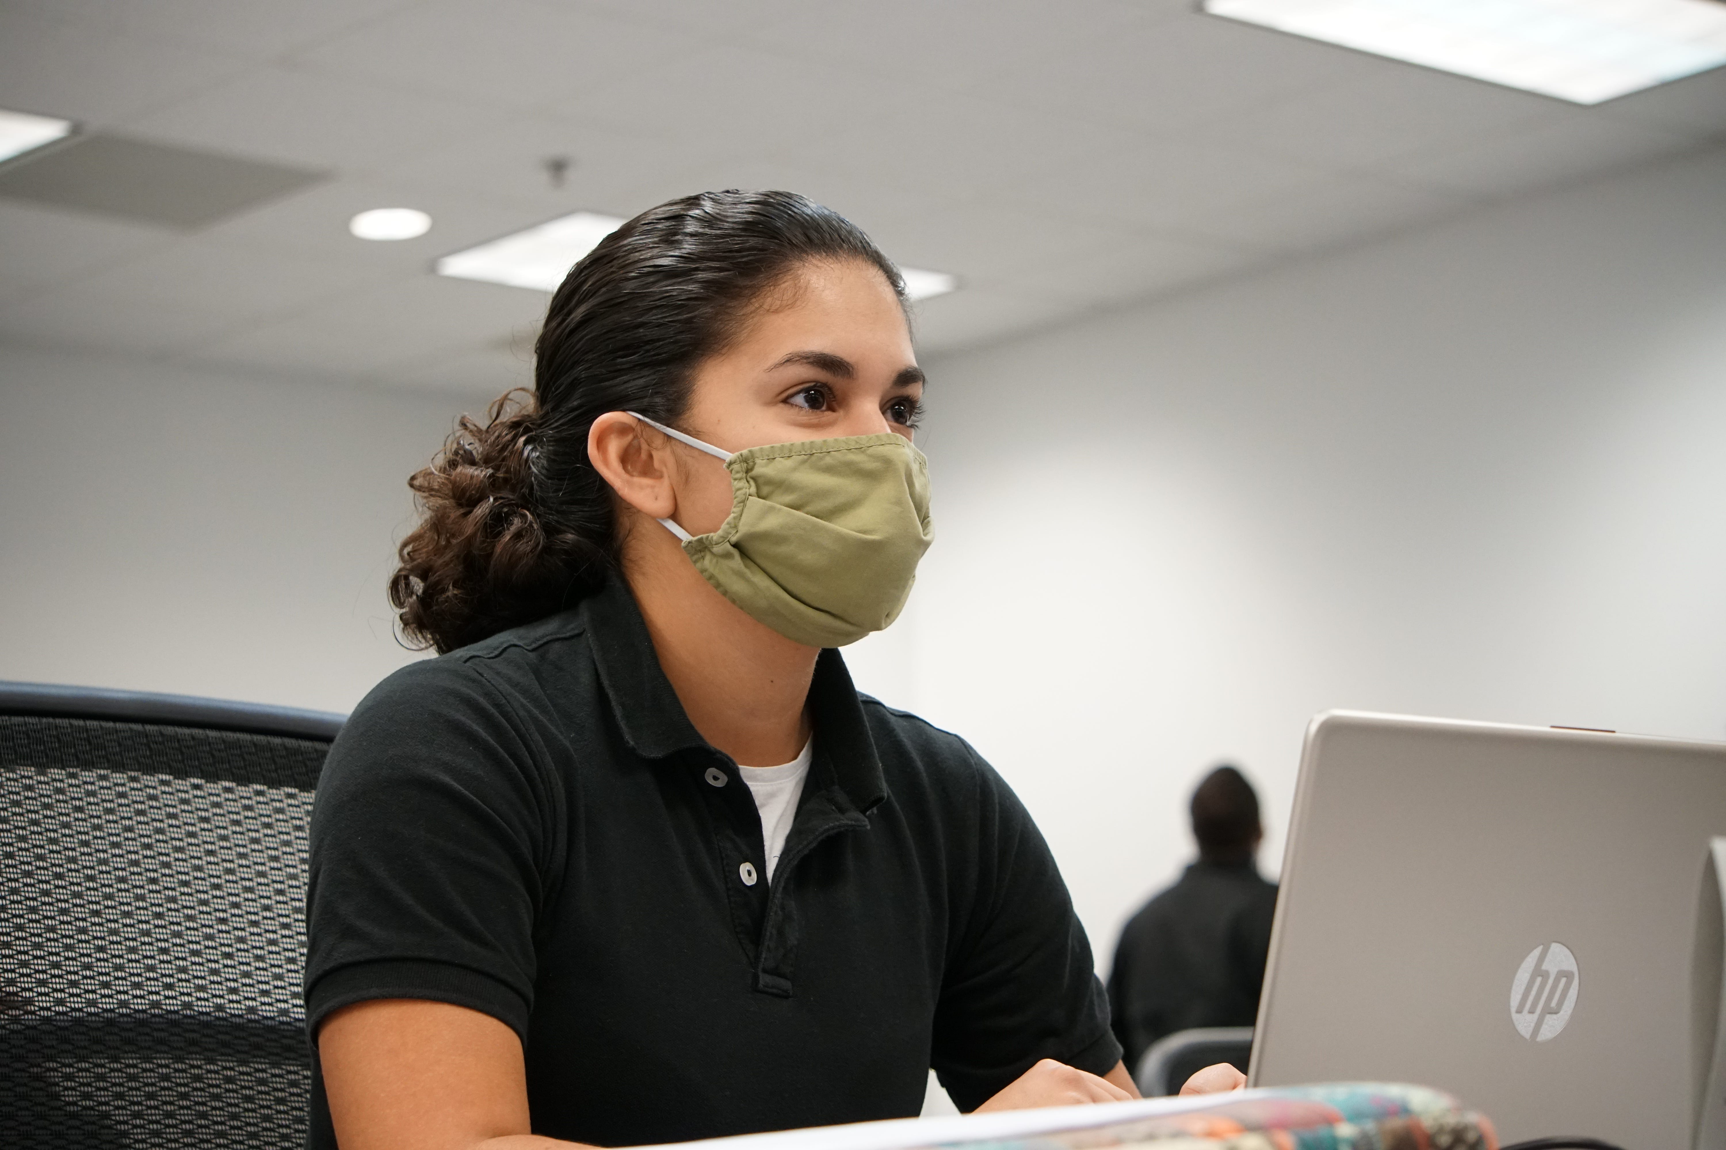Natasha Marie Poventud Suarez is one of the few women and sometimes the only Puerto Rican sitting in the room. She attends a class as she finished up her training in December, 2020.AYANO NAGAISHI
After physical training from 6 to 7 a.m., class members get ready for the rest of their day. While the first half of their morning focuses on strength and athletics, the next part of their day demands a different dedication to perfection.
Each student’s living space must look like no living took place, Suarez said.
Windows opened to the third cinderblock on the wall? Check.
Shower curtains pushed to the opposite side of the shower-head? Check.
Ends of the toilet paper roll folded into a triangle? Check.
“Everything has to be wiped down completely because they will touch it and if they see dust, they might ransack your room and you have to redo it,” Suarez said.
Every student in the academy gets a hat along with the uniform. It represents their identity and measures their responsibility. Students keep the hat with them at all times. It must never be worn inside buildings, but must be worn when students are outside. If any of the recruits fail, they will be reprimanded.
Through what some might term a compulsive drive for consistency and perfection, the academy stressed another lesson for law enforcement: accountability.
“Accountability is just a big thing that they engraved in our heads. For yourself, your car, your uniform, everything. If you mess up, say you mess up. Don’t lie about it because that just is going to ruin your whole career.”
Not every part of the academy is about conformity for Suarez, though. She is often one of the few women and sometimes the only Puerto Rican sitting in the room. She has played the role of the officer pulling over the car, but she’s also been the child in the back seat.
She’s grown up on lessons of avoiding the people in the profession she ended up embracing.
The academy advertises that the compulsive conditioning that police recruits endure serves as an essential aspect of officers’ lives. But consistent punishment isn’t given for all imperfect behaviors in the academy. Wrinkled bed sheets may land a student harsher punishment than an objectifying comment called from the back of the room during a lecture.
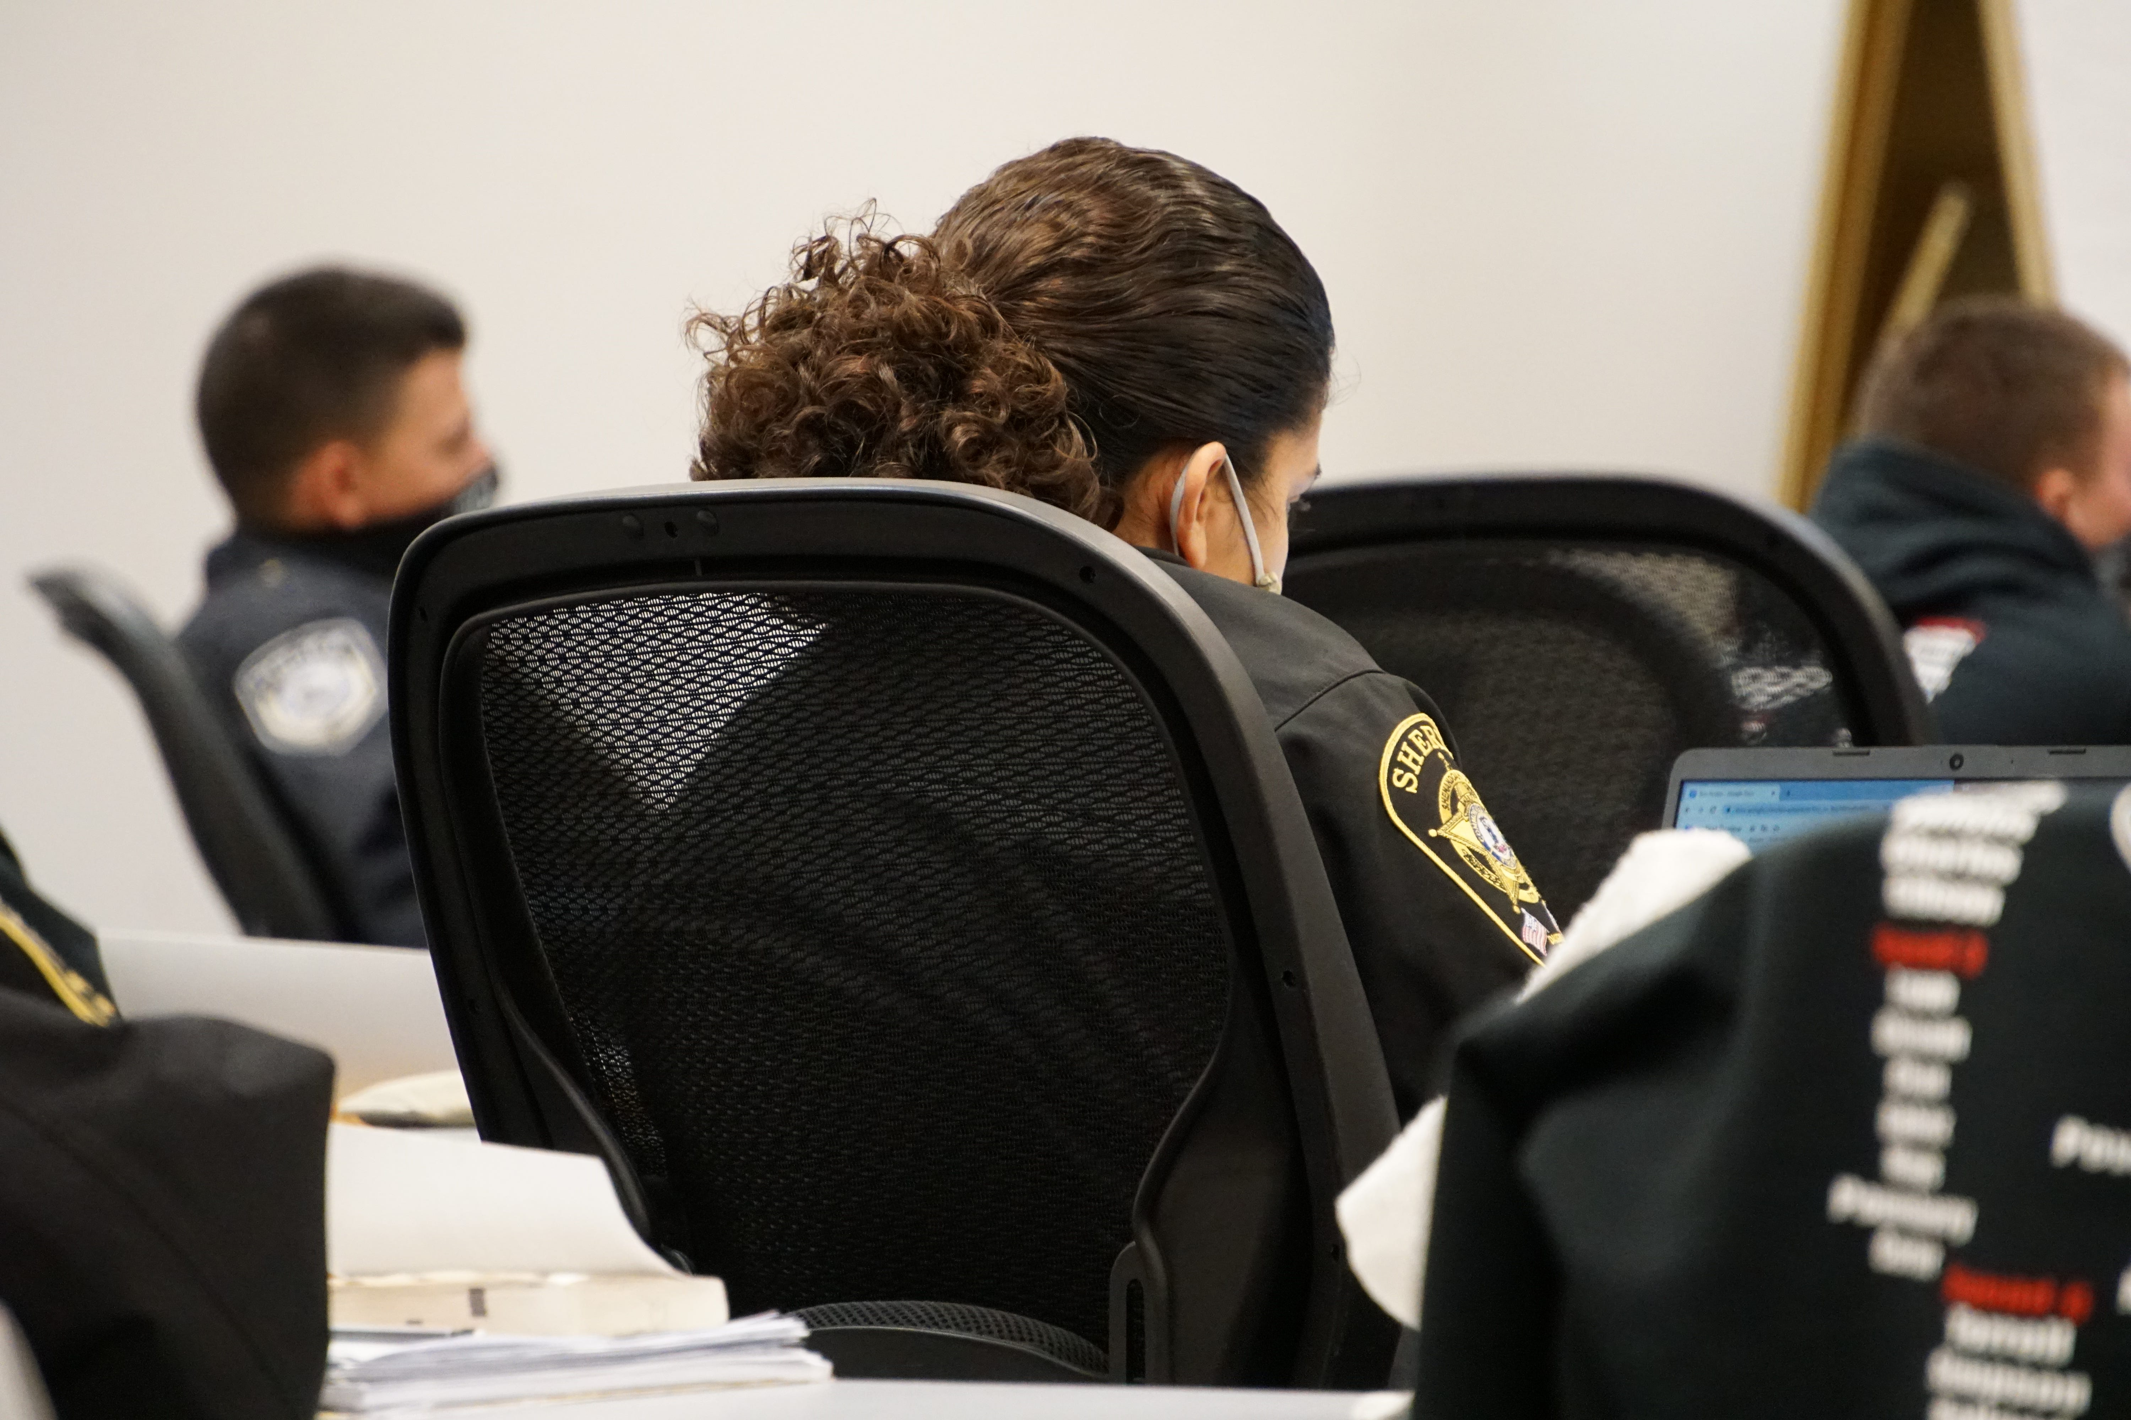Natasha Suarez listening to Jackson's classAYANO NAGAISHI
Suarez started her Basic Law Enforcement training in July 2020 and graduated in December 2020. The six months in between began to shape her into the police officer she was hired to become.
Even in the last days of graduation week, the finishing touches weren’t complete. Each student could sense just how close he or she was to completing certification, but they weren’t done yet. There were still some critical pieces of training that weren’t included until the very last minute.
Students had their first Fair and Impartial Policing lecture three days before their graduation. It covered internal biases that officers might bring with them into the field and how those biases could jeopardize law enforcement’s ability to react and serve the community properly. The only other related part of the training curriculum, The Cultural Diversity, was given 19 weeks before and lasted less than a full day.
Suarez attended the latest lecture looking up at a man who shared some of her challenges as a police officer: Tristian Armand Kasem Jackson, the “basic law enforcement training” coordinator at the academy, was no stranger to standing out in his force, primarily because of his race.

Race within the ranks
Jackson said he has two identities. He is a police officer and a Black male. He grew up in a single-mother household, where his mom would do anything to avoid the police. Now, against her wishes, he is one.
Sometimes when he’s at a crime scene, it feels like he’s the one being interrogated by the witnesses, rather than the other way around.
“I’ve had white offenders tell me that they don’t trust me because I’m colored. I’ve had witnesses look at me and say, ‘The guy who did that to me looks just like you,’ and I’m like, does he look just like me, or is he just Black like me?”
Jackson begins breaking stereotypes by simply being a voice in the room filled with white students.
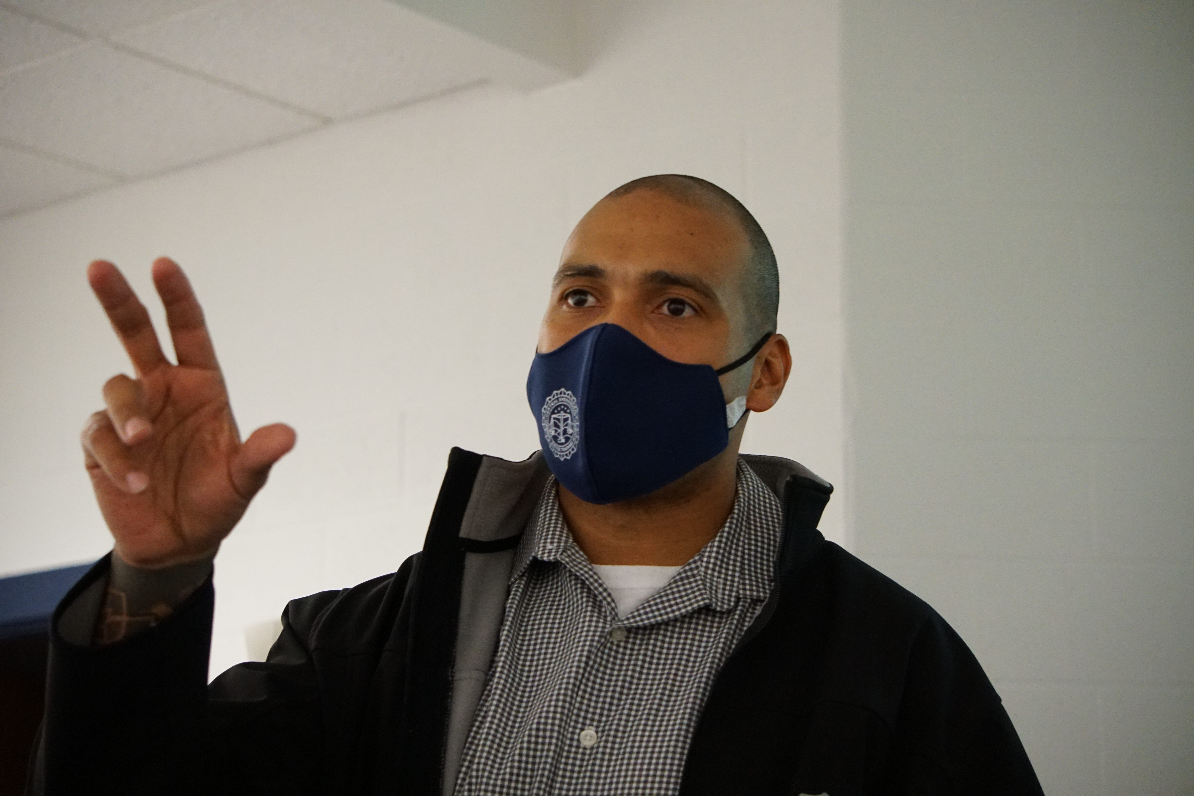Tristian Jackson is “basic law enforcement training” coordinator at Central Shenandoah Criminal Justice Training Academy.AYANO NAGAISHI
Students sat before a large stage with a projector screen pulled down from the ceiling. An American flag stood on Jackson’s right. With its buzzing fluorescent lights, the space was more like a high school classroom than a college lecture hall or a Netflix version of a Quantico classroom. The room yawned far back under a low ceiling. At row after row of tables sat monochrome students, slouched in a pre-note-taking daze. No natural light. Doors slammed and voices were raised, then faded as they passed by in the hall.
More: Stories of the Decade: News Leader's Top 10
The Fair and Impartial Bias lecture started with a class exercise. A blank slide would appear and then a picture of a person would follow. A Muslim woman, a group of black teenagers, an old man. Finally, a white woman in a tight dress.
“She’s smokin’ hot,” a student remarked from the back of the room, amid a wave of snickers. More adjectives floated around the room, “sexy” and “beautiful.”
As they shouted, Jackson moved to the next slide where he showed a picture of a young boy. It was a picture of the same white woman, who is transgender, when she was a child. The class fell silent and in the back of the room, the student who’d commented made a sound of surprise.
“I hate myself,” he muttered.
Jackson wasn’t there to make young recruits hate themselves. He knows minds need to be open to new things, and that the future of policing depends on who comes through the door.
“When I talk to them about character, I’m like, that is your credibility in court. If you run bankrupt on that, based on your behavior, no one can give you that currency back,” he said.
Jackson works on conditioning the minds in this relatively new class. Outside of his classroom there have been demands to improve tactical skills in the academy as well.
De-escalation is a hot topic this year. According to Jackson, the academy has committed to focusing at least eight hours of training to de-escalation strategies.
He believes younger generations struggle with de-escalation because they don’t have as much experience with confrontation to begin with and end up not knowing how to back down. Suarez said that one of the most important skills as a police officer is learning how to talk your way out of an altercation instead of causing one.
Jackson told the class of December 2020 they had to recognize and correct their own biases, stereotypes and harmful assumptions while preparing to be the objects of such bias themselves from the people they are sworn to serve and protect.
“I want them to understand that we need to treat all people with dignity.”
Jackson and Suarez share a certain hope for the younger generation of police officers — adaptability.
Suarez will enter the field with more than her handguns as a weapon. She also wields her ability to learn and to embrace new ideas.
“I’m not set in my ways and my mind can be molded. So that’s a big thing,” Suarez said.
Jackson said that combination of traditional police experience from veterans and the fresh eyes of the upcoming, tech-savvy generation create an effective and powerful environment for students.
Jackson never wants his students to lose sight of their communities. He hopes to see them move forward in their careers and go on to help those who live in the same areas they do. He wants them to tackle sexual assault, domestic violence and crime.
He left students with a final message that echoes Edmond Locard’s famous principle.
“Forensic science holds that the perpetrator of a crime will bring something into the crime scene and leave with something from it, and that both can be used as forensic evidence.”
Whenever police engage with the public, Jackson explained, the public engages back. It is a law of nature that Jackson grew up with.
When asked about his race as a police officer, Jackson always had to respond, whether the question came from a citizen or a cop.
When Suarez’s father was stopped by police, her father had to respond to questions that implicitly challenged his rights. Jackson hopes with the future officers he’s training that the nature of those encounters will change.
Suarez’s mission won’t be easy, but she’s not the helpless child she was in the back of her parents’ car anymore.
The language of law enforcement is no longer foreign. It will be up to her and her fellow officers to mend the relationships damaged by injustice and discrimination, relationships between the community and the police that demand a certain acknowledgement of humanity, on the ground and in the soul.

