- News
- Commentary
- Around F.C.
- Arts & Entertainment
- Business
- Letters
- Sports
Crime
Local Commentary

Our Man in Arlington
December 12, 2019 4:30 PM by Charlie Clark
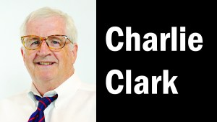
If you harbor gripes that our county government gets too ambitious, consider an episode from the 1930s.
In what probably ranks as the most disruptive Arlington project ever, our entire street grid was renamed. The modern system of (mostly) logical groups of streets by numbers and syllables was an engineering and citizen consultation feat that foreshadowed what we call the “Arlington Way.”
The tale was told in a 1959 Arlington Historical Magazine by C.L. Kinnier, who directed Arlington’s Engineering Department when the streets were renamed.
Authority came after 1932, when Arlington switched to the county manager system and the board appointed Roy Braden to the new job. Braden’s recommendation for a new street system diagnosed a status quo that inflicted multiple hassles.
Duplication: too many “improperly named” streets labeled Washington, Lee, Arlington or Fairfax. Some residents had to add their subdivision (Radnor Heights, Country Club Hills) to their address to receive mail or deliveries. Rural folks had to use “Alexandria RFD.” The old streets were a hodgepodge of “tree names” followed by streets named for friends or family, local or historical, Braden noted.
The problems were traced to understaffing and the county’s growth from 16,040 persons in 1920 to 26,615 in 1930.
The board farmed the job out to the Engineering Department after naming a committee on March 1, 1932, chaired by Monroe Sockett. It heard pleas from the Arlington Civic Federation and the Chamber of Commerce, which pointed out that reforms were vital if Arlington was to get a central Post Office. The committee also sought advice from the American Municipal League, the County Managers Association and engineering firms.
Kibitzers suggested new street names, even whole schemes. Some wanted a continuation of District of Columbia streets. “Each thought it better to change the name of the other man’s street rather than his,” Kinnier wrote.
The planners hung a giant map in their work room. They had to divide the county into North and South (rejecting a proposal for quadrants). They considered what today is Washington Blvd. as the divider. (At the time, that road had sections called Memorial Dr., Garrison Rd. and Brown Ave.) Instead they chose Lee Blvd. (now Arlington Blvd.).
The list of must-keep old names included traditional Virginia standbys and state roads — Lee Highway, Old Dominion Dr. and Jefferson Davis Highway (that lasted until 2019).
Rules required that streets at right angles to the divider have names; that streets parallel be numbered.
Sockett’s monthly work sessions for a year had been open, but the final system was formally vetted at a June 21, 1933, hearing.
Thirty months after its start, the committee saw its recommendations win board approval on Aug. 30, 1934. The county then reassigned house numbers. “Houses on the south and west sides of the streets would have even numbers and those opposite would have odd numbers,” Kinnier wrote. They had to update and scrub all Courthouse information and create signs at 3,000 intersections. Total appropriated funds: $7,500.
The new system took effect July 1, 1935. The board passed an ordinance declaring that “if any majority of the citizens of one street did not like the name selected, and wished to change it to some other name that would fit the ordinance, it could have the change made provided they would pay for the signs.”
****

Fun memory of Hollywood glamour in 1960s Arlington comes from my boyhood friend Gary Glover.
Gary’s grandfather Joe Fuschini, founder of the old Progressive Cleaners in Cherrydale, kept an immaculate home and yard on Huntington St. in Westover. One day Ira Beaty, father of Washington-Lee (now Washington-Liberty) grads and movie stars Shirley MacLaine and Warren Beatty, knocked on his door and offered to buy the property. Fuschini slept on the proposal and then called Beaty to accept his offer.
Two weeks later, however, it was daughter MacLaine who showed up and wrote the check for her dad at Joe’s price. In business back then, Gary said, “Your word was your bond.”
- News
- Commentary
- Around F.C.
- Arts & Entertainment
- Business
- Letters
- Sports
- Crime
Local Commentary

Our Man in Arlington
November 27, 2019 12:30 PM by Charlie Clark
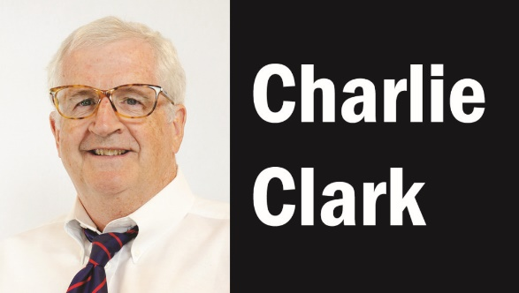
Growing up white in north Arlington, schoolmates and I were aware of the African-American enclave of Hall’s Hill — sadly, we were scared to venture there for fear of getting beaten up.
So I felt my share of the emotions that poured from denizens of that historic neighborhood who spoke Nov. 13 at the event titled “Learn From This Place: Bringing Arlington to Halls Hill.”
The auditorium at Virginia Hospital Center rung with multi-generational music, nostalgia and tears of pain expressed by four who lived through Arlington’s (ongoing) transition out of segregation.
As part of a multi-day event funded by a Virginia humanities grant, they shared bittersweet recollections of the 1950s, when blacks weren’t allowed in Arlington Hospital, or in movie theaters or pony rides. Wilma Jones Killgo, author of a history of Hall’s Hill, presented African-American heritage songs performed on cigar box banjos by middle school students in Career and Technical Education.
Traditionals such as “You Are My Sunshine” and “Going Down the Road Feelin’ Bad” were adapted to Hall’s Hill memories of being forced to walk ten blocks to school after the Langston school closed, and being late for faraway Little League games. To guitar and harmonica strains of a blues duo, Junious Brickhouse performed a muscular dance.
The gray eminence among panelists was retired teacher William Vollin (who taught at Langston and Glebe, where he was principal). Born in the defunct Arlington neighborhood of Queen City, he recalled the Hoffman-Boston all-black K-12 school with its “hand-me-down books” and no science lab. At Langston, the “food staff and custodians were like counselors,” he said. Decisions on school boundaries were made by “racist” school boards so as not to “upset folks on the other side of Lee Highway.” Once asked by officials for the racial breakdown of Glebe Elementary, Vollin replied, “We’re 100 percent human beings.”
Michael Jones, one of four blacks tapped to integrate Stratford Junior High in 1959, said at Langston Elementary “there was no remediation — we just fit in.” Growing up with seven people sharing a bathroom “made us closer.”
The adjustment to being “socially marginalized” at white schools was jarring after early years in a Hall’s Hill “that taught us we had a lot to offer, to love, give and trust,” said Kitty Clark Stevenson, now a human resources consultant. At Swanson, the drama teacher told her she couldn’t appear on stage, and a counselor said she would “make a very good maid.” Stevenson described “ragged” textbooks from which they had to “erase crude, profane language. Thank you, Arlington,” she said, “for the best cuss words I learned.”
Saundra Green, retired from Arlington Parks and Recreation, recalled “wonderful role models” in Hall’s Hill, where “your school teacher may also be your Sunday school teacher,” and a shopkeeper “your scout leader.”
When switching schools, she had to give up plans to be a cheerleader or sing in select chorus. When she came to work professionally as director at the Lee Community Center, Green overheard a staffer calling her a monkey and being asked, “Are you the new custodian?”
That staffer and she later became friends.
***
A spiritual vibe enveloped the Nov. 14 gathering of Arlington’s affordable housing advocates when leaders and beneficiaries cut the ribbon for Gilliam Place. That new $71 million, 173-unit apartment building is the fruit of the 2012 decision by the declining Arlington Presbyterian Church to sell its land off Columbia Pike at S. Glebe Rd. to fill a housing gap.
The result: living space for the low-income or disabled combined with community rooms and retail that make it the first mixed-use project of the nonprofit Arlington Partnership for Affordable Housing. County Board Chair Christian Dorsey welcomed Gilliam as part of the board’s “equity resolution.” Clergy quoted the Prophet Jeremiah, and secular activists thanked the architect, builder, construction workers, permitting office, planners and funders federal, state, local and private.
Church elder Susan Etherton hailed the “new front porch of our church,” the gleaming building alongside a contemplative park with a sign (“Sit, Pause, Rest,”) bearing the name of Arlington Presbyterian.
Local Commentary

Our Man in Arlington
May 8, 2019 6:13 PM by Charlie Clark
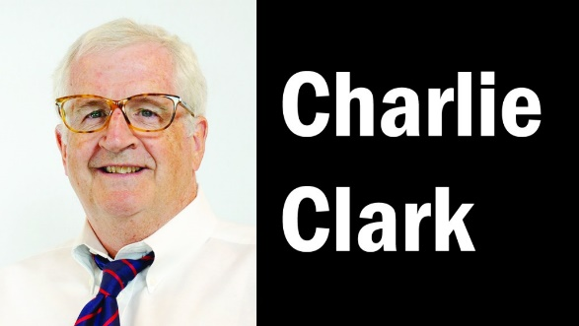
Next time you drive I-66, know that you are crossing land that hundreds of Arlingtonians once called home.
The drama of that divisive federal-state construction project — which required confiscation, under eminent domain, of 1,054 land parcels of homes, parks, gardens and dozens of businesses — remains vivid in memories of longtime Arlingtonians.
And the duration! Conflict over the eventual $275 million road lasted from visioning that began in 1958, to the right-of-way finalized in 1966, to lawsuits and protests by environmentalists, to the down-scaled compromise design in the 1977 Coleman report, to the paving that allowed its opening in 1982.
“Our original next-door neighbors, Mr. and Ms. Larry Potter, were active in opposition to I-66,” recalls Cherrydale resident Bob Witeck. “They gave us their Stop I-66 bumper stickers, and we have early 1960s photos of homes that were picked up intact, trussed securely onto trucks and moved a couple blocks away.”
Coleman report, to the paving that allowed its opening in 1982.
“Our original next-door neighbors, Mr. and Ms. Larry Potter, were active in opposition to I-66,” recalls Cherrydale resident Bob Witeck. “They gave us their Stop I-66 bumper stickers, and we have early 1960s photos of homes that were picked up intact, trussed securely onto trucks and moved a couple blocks away.”
Retired Virginia Transportation Department land-use planner Tom VanPool recently sent me a copy of one in the state’s full collection of I-66 right-of-way plan sheets. It shows the site of the Frank Lloyd Wright-designed Usonian Pope-Leighey House, which was transported from Falls Church to Woodlawn plantation.
Former Maywood resident Sam Day recalls an array of stores around Kirkwood Rd. at Lee Highway that disappeared — Steve’s Diner, the Village Market and Young’s Bicycle Shop. At Arlington’s Falls Church border, Ware’s Pharmacy was forced to relocate, realtor Ed Downs remembers. And retired Fairfax teacher Carmen Clark Colliatie recalls how her First Church of Christ Scientist of Arlington was condemned and rebuilt on North McKinley St.
Those who lost homes suffered the most anguish. “When the lawsuits got going, some people didn’t move out, and maybe one or two people per block were left,” says homebuilder Terry Showman. Phil Lord, who lost his house at 1409 N. Utah St., added, “It was strange to have so many vacant houses around — like No Man’s Land.”
Lynnette Yount, a leadership coach and minister’s daughter, says her “parents were truly screwed over” when the state offered a price that was “abysmally low. Luckily, my mother was a good financial planner, and my parents had saved enough for a lot and having their dream house built.” But she was forced to switch high schools.
Jean McMahon recalls the “shock and disappointment” of her parents when told in 1963 that the N. 24th St. house they’d owned and expanded since the 1940s was doomed. They too were offered “a very low amount” but got a lawyer to up it by a few thousand. “I distinctly remember the `rush’ of trying to find a new home because of the new road,” she says. But construction wouldn’t start for a nearly decade.
Diane Kresh, director of Arlington Public Libraries, remembers the surprise of losing her home at N. 29th and Wyoming streets. “The amount of money my parents were offered was maybe $17,000 or $19,000,” and they were upset that the [similar] houses flanking theirs were valued higher,” she told me. “My family moved [nearby] during the week of the John F. Kennedy burial. The old lot remained vacant for years. There was a huge willow tree in the backyard that remained until the bulldozers started clearing for I-66 construction,” Kresh recalls. “I still think about that tree … still sad it’s gone.”
***

One of Arlington’s standout Republican officeholders, Dorothy Grotos, died April 25 at 88.
A county board member from 1975-83, the one-time Washington-Lee High School PTA president made her name as a Girl Scouts executive and proto-environmentalist (before it was cool) in the early 1960s.
In 2015, I drove to the Grotos later home in Marshall, Va., and interviewed her about her role in creating Arlington’s Gulf Branch Nature Center. Back in the 1960s, people asked her, “What the devil is a nature center?”

